# AZURE CLOUD COMPUTING.

## MINOR PROJECT.

TOPICS-

* Create 2 Venets – Vnet 1 and Vnet 2.
* Create 2 Subnets in each Vnet.
* Create VM each Vnet 1 and 2.
* Assign Public IP to VM in Vnet1.
* Peer Vnet 1 and 2.
* Login to VM1 and if peering is succesful you should be able to login to VM in Vnet 2.
* Create a data disk and attach to VM1.
* Logon to VM and initialize the disk.

# Create 2 Vnets – Vnet1 and Vnet2 & Create 2 Subsets in each Vnet.

Virtual Network-A virtual network is a network where all devices, servers, virtual machines, and data centers that are connected are done so through software and wireless technology. This allows the reach of the network to be expanded as far as it needs to for peak efficiency, in addition to numerous other benefits.

Step1: Open Azure portal menu , click on Virtual Network.

.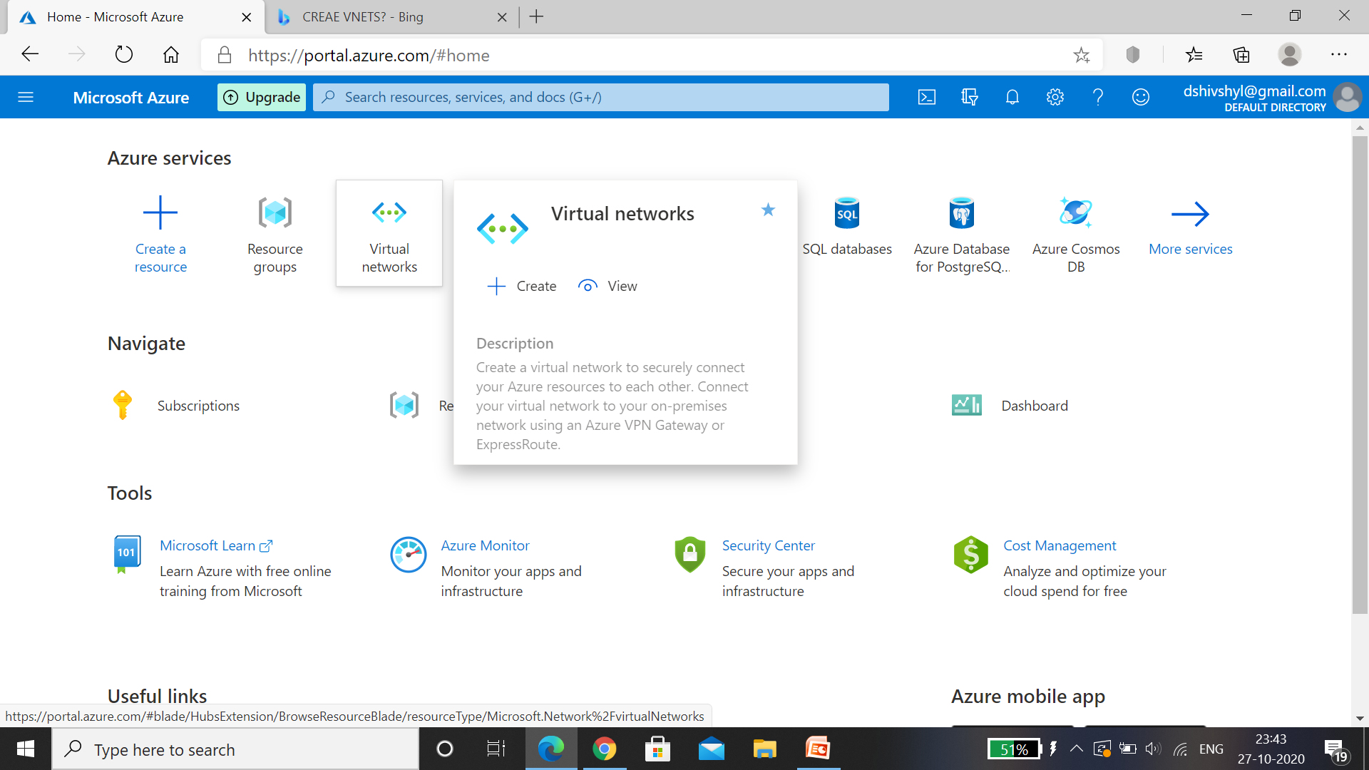

Step 2: click on ADD to Create Vnet 1.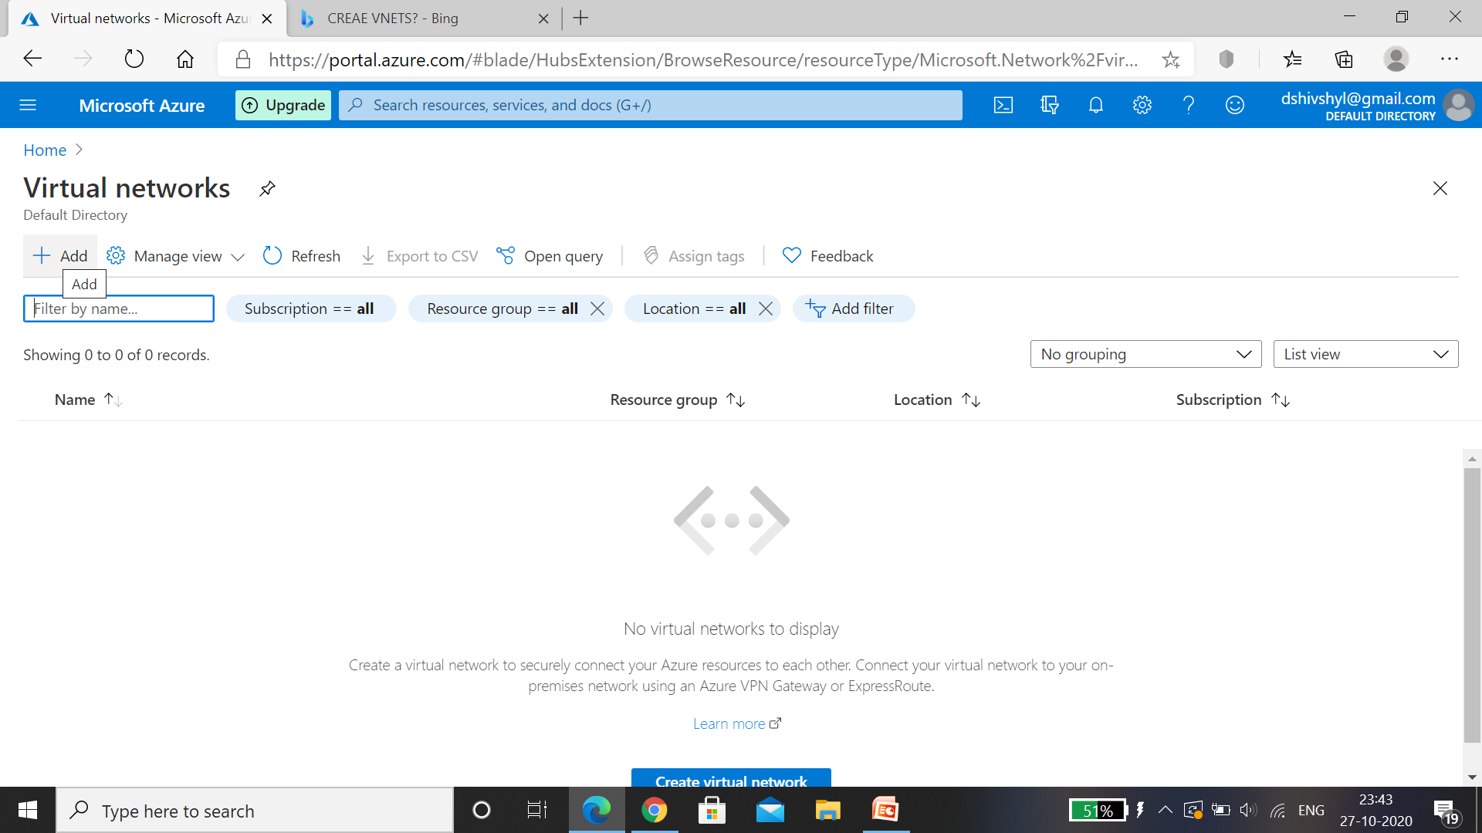

Step 3: Fill the basics details , Resource group can be created before this step or even in this step ,in this case I have Attached the previously created resource group ,named Vnet1 and selected the region then I click on next: IP Addresses.

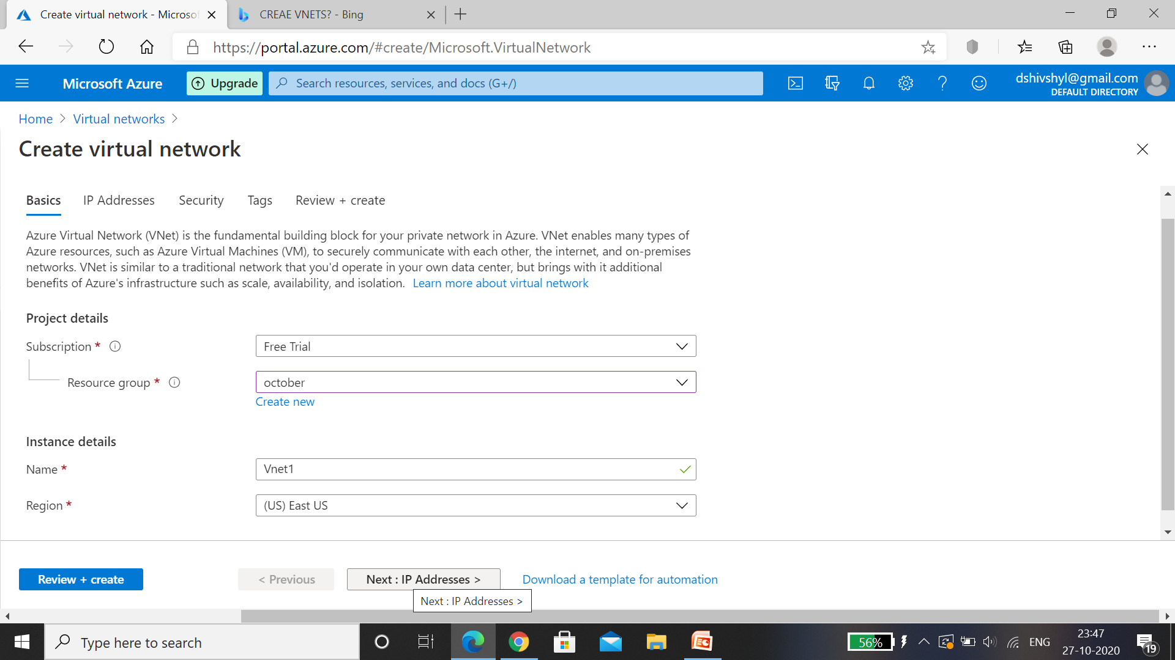

Step 4: create our own publicIP Address range and for IPv4 address space, enter 192.0.0.0/5 .

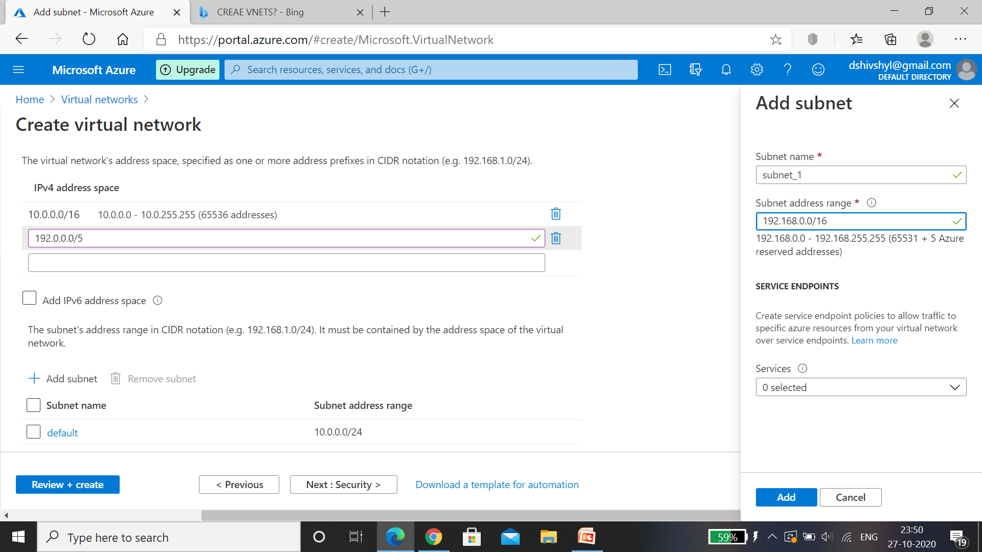

Step5: Select Add subnet and then enter myvirtualsubnet for subnet name and subnets address range. Like this 2 Subnets are created in Vnet1 , click on next: security.

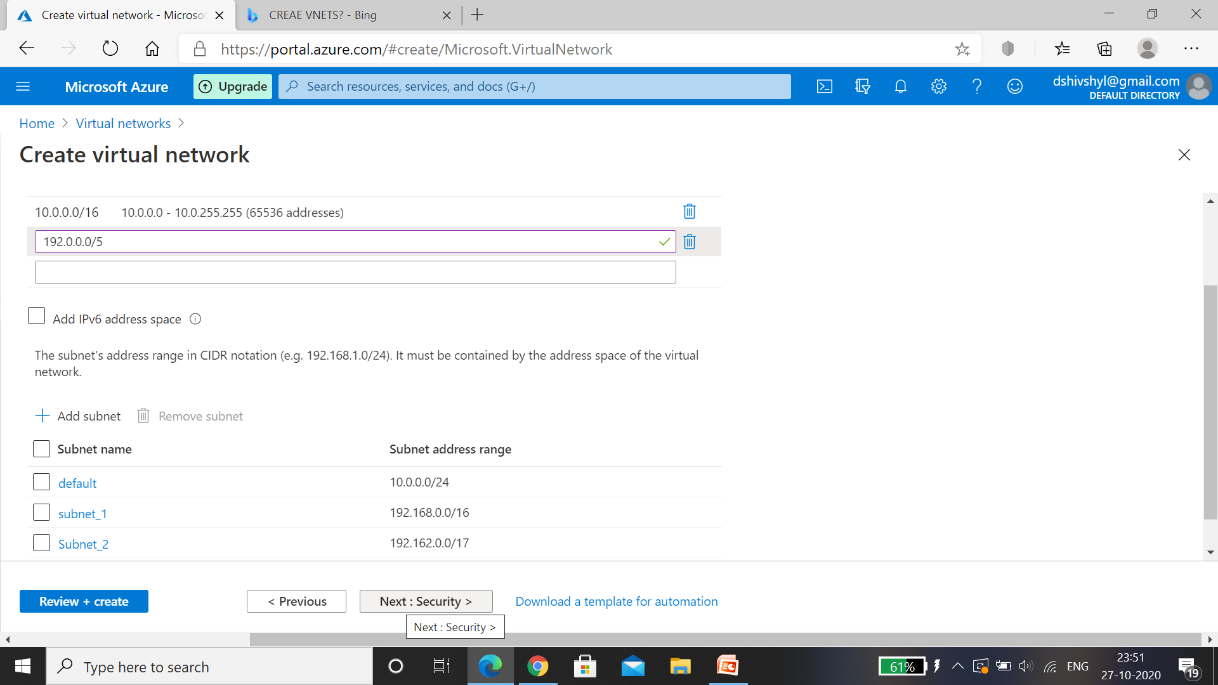

Step 6 : Security, click on next:tags.

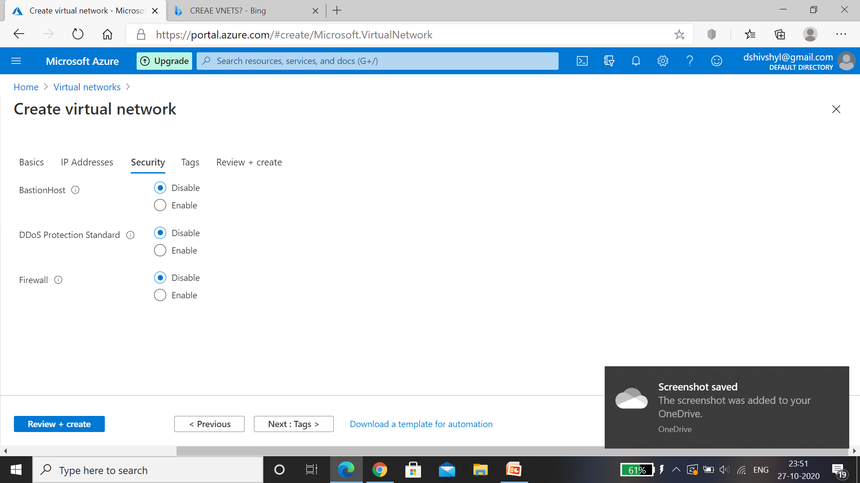

Step 7: Tags, enter the data from the resource Vnet1 , then select Next :Review+create.

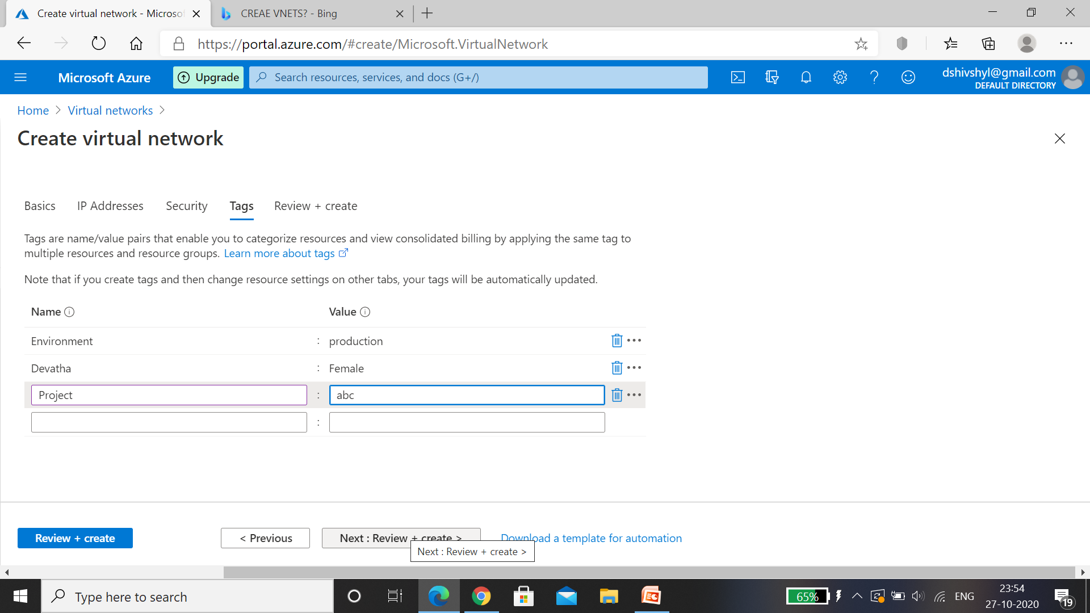

Step 8: leave the rest as default and after validation passed select on Create.

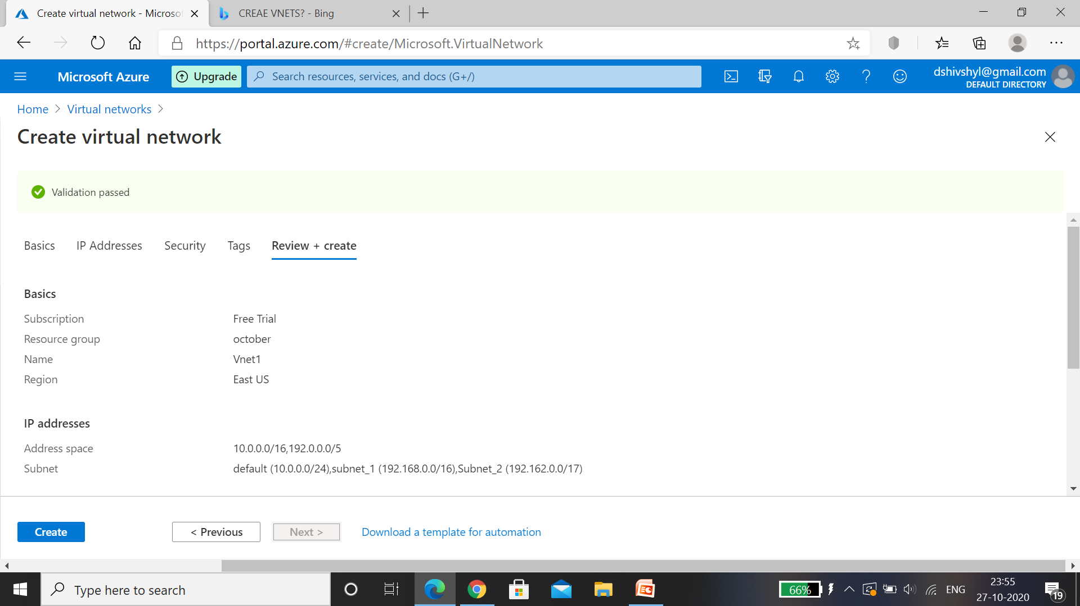

Step9: In this step select Go to resource.

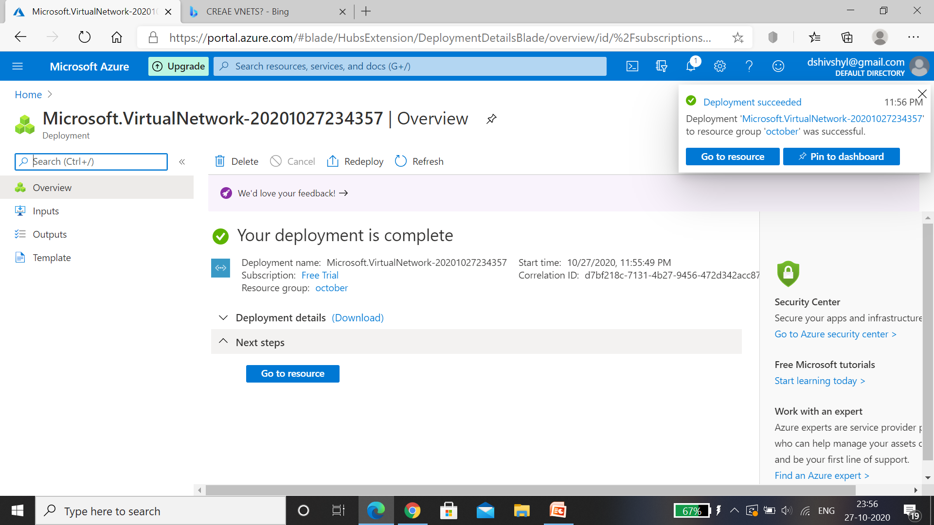

Step 10: Vnet1 is created with 2 subnets.

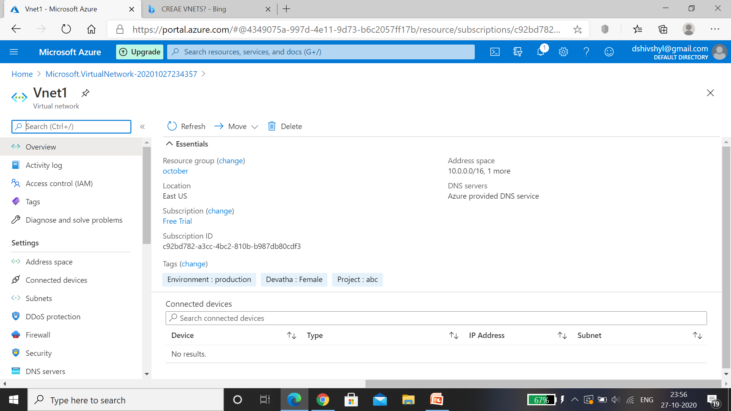

Step 11: Now Create Vnet2, Fill the basics details , for this I have created the resource group in this step, named instance name as Vnet2 and selected the region then select next: IP Addresses.

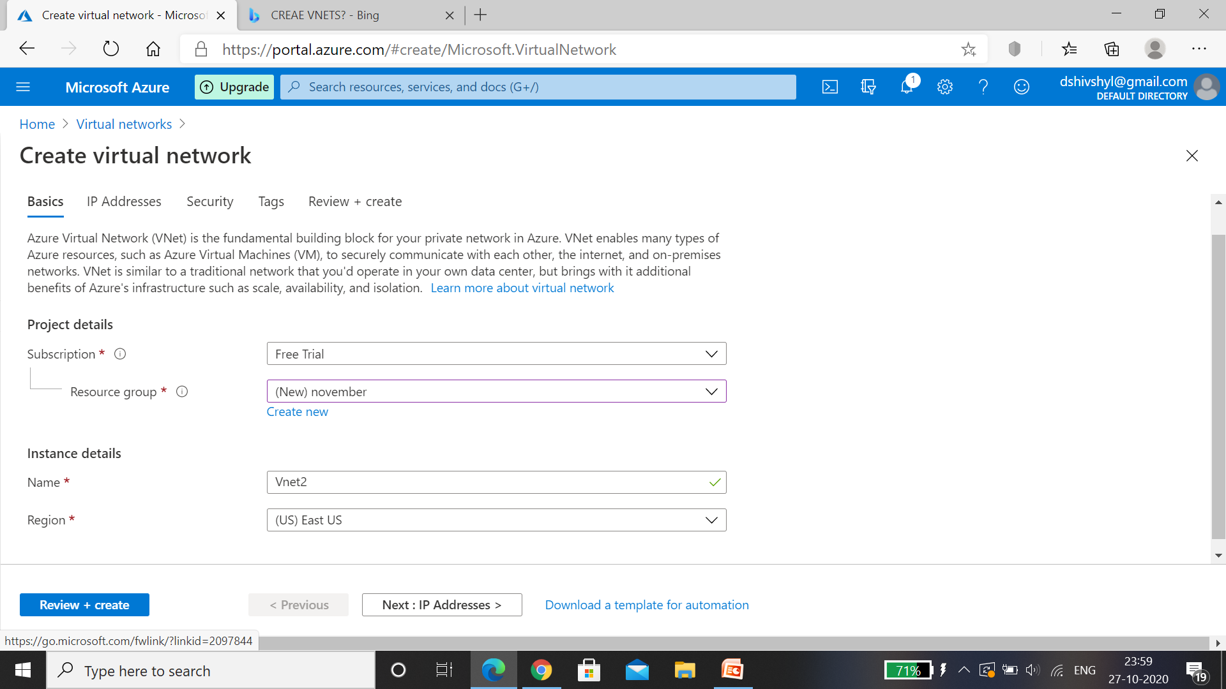

Step 12: create publicIP Address and add 2subnets under Vnet2, then click on next:security.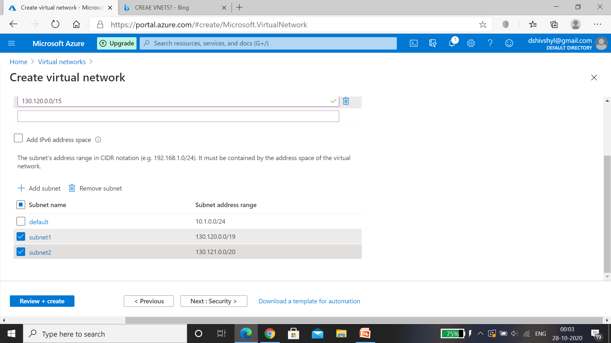

Step 13: leave all as default and then click on next: Tags.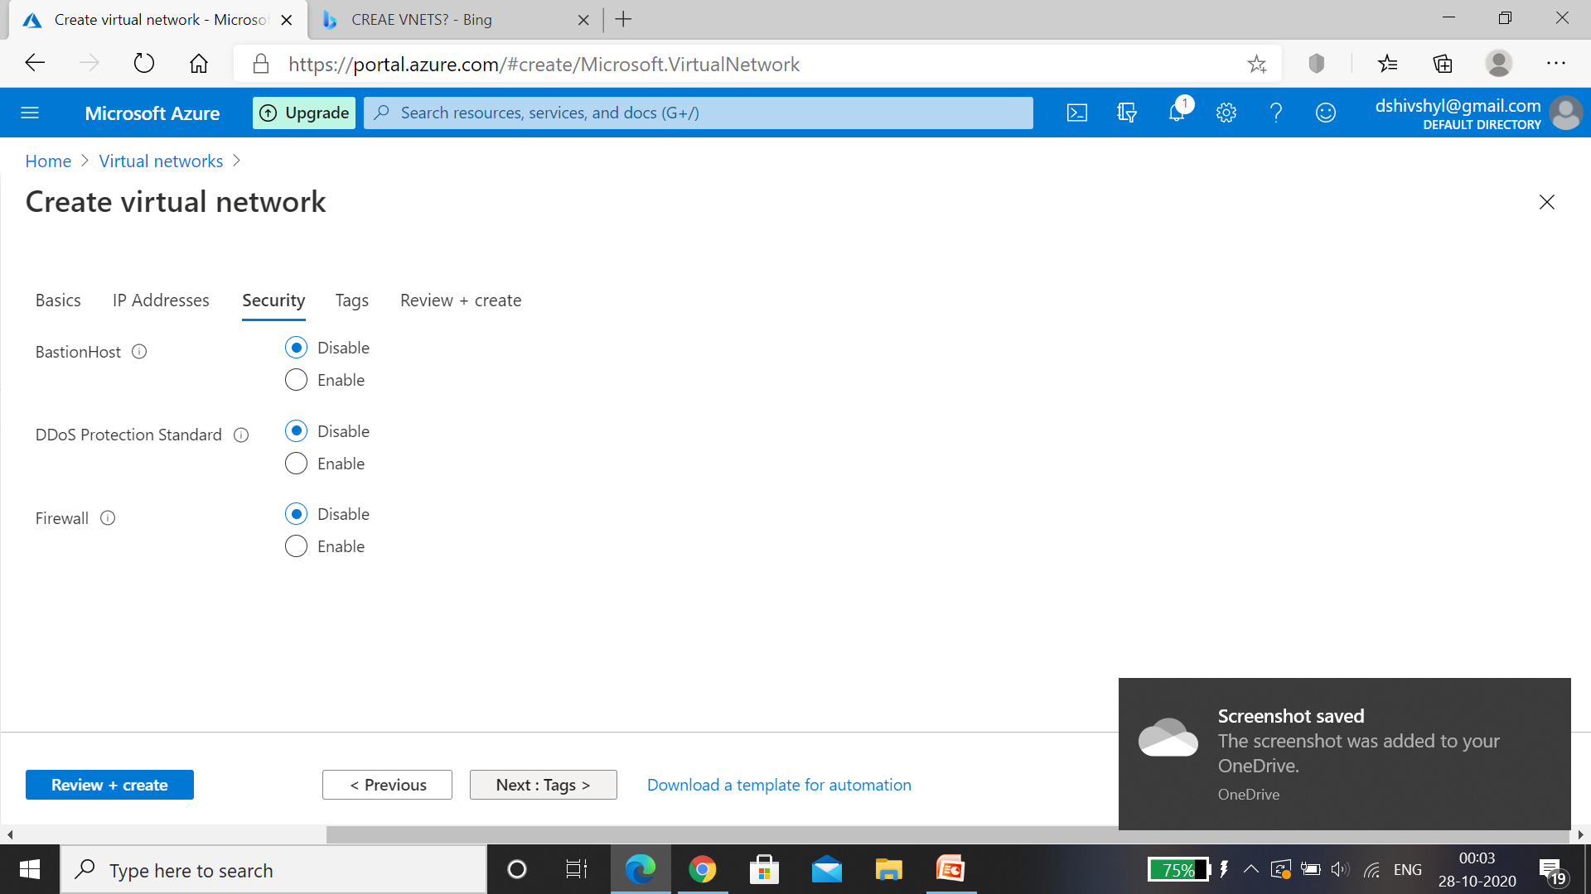

Step 14: tag all the resource data from newly created resource, then click on review +create.

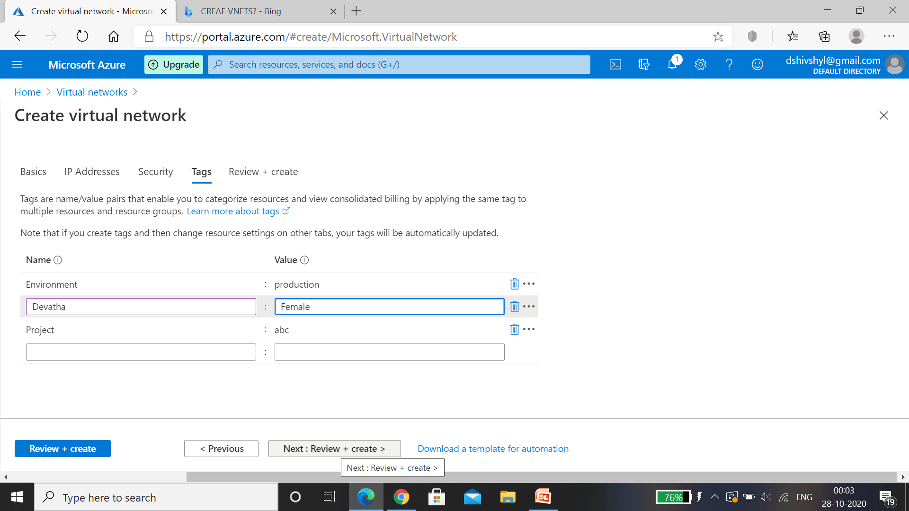

Step 15: After validation passed Click on create and wait for the deployment to complete ,then select on Go to resource.

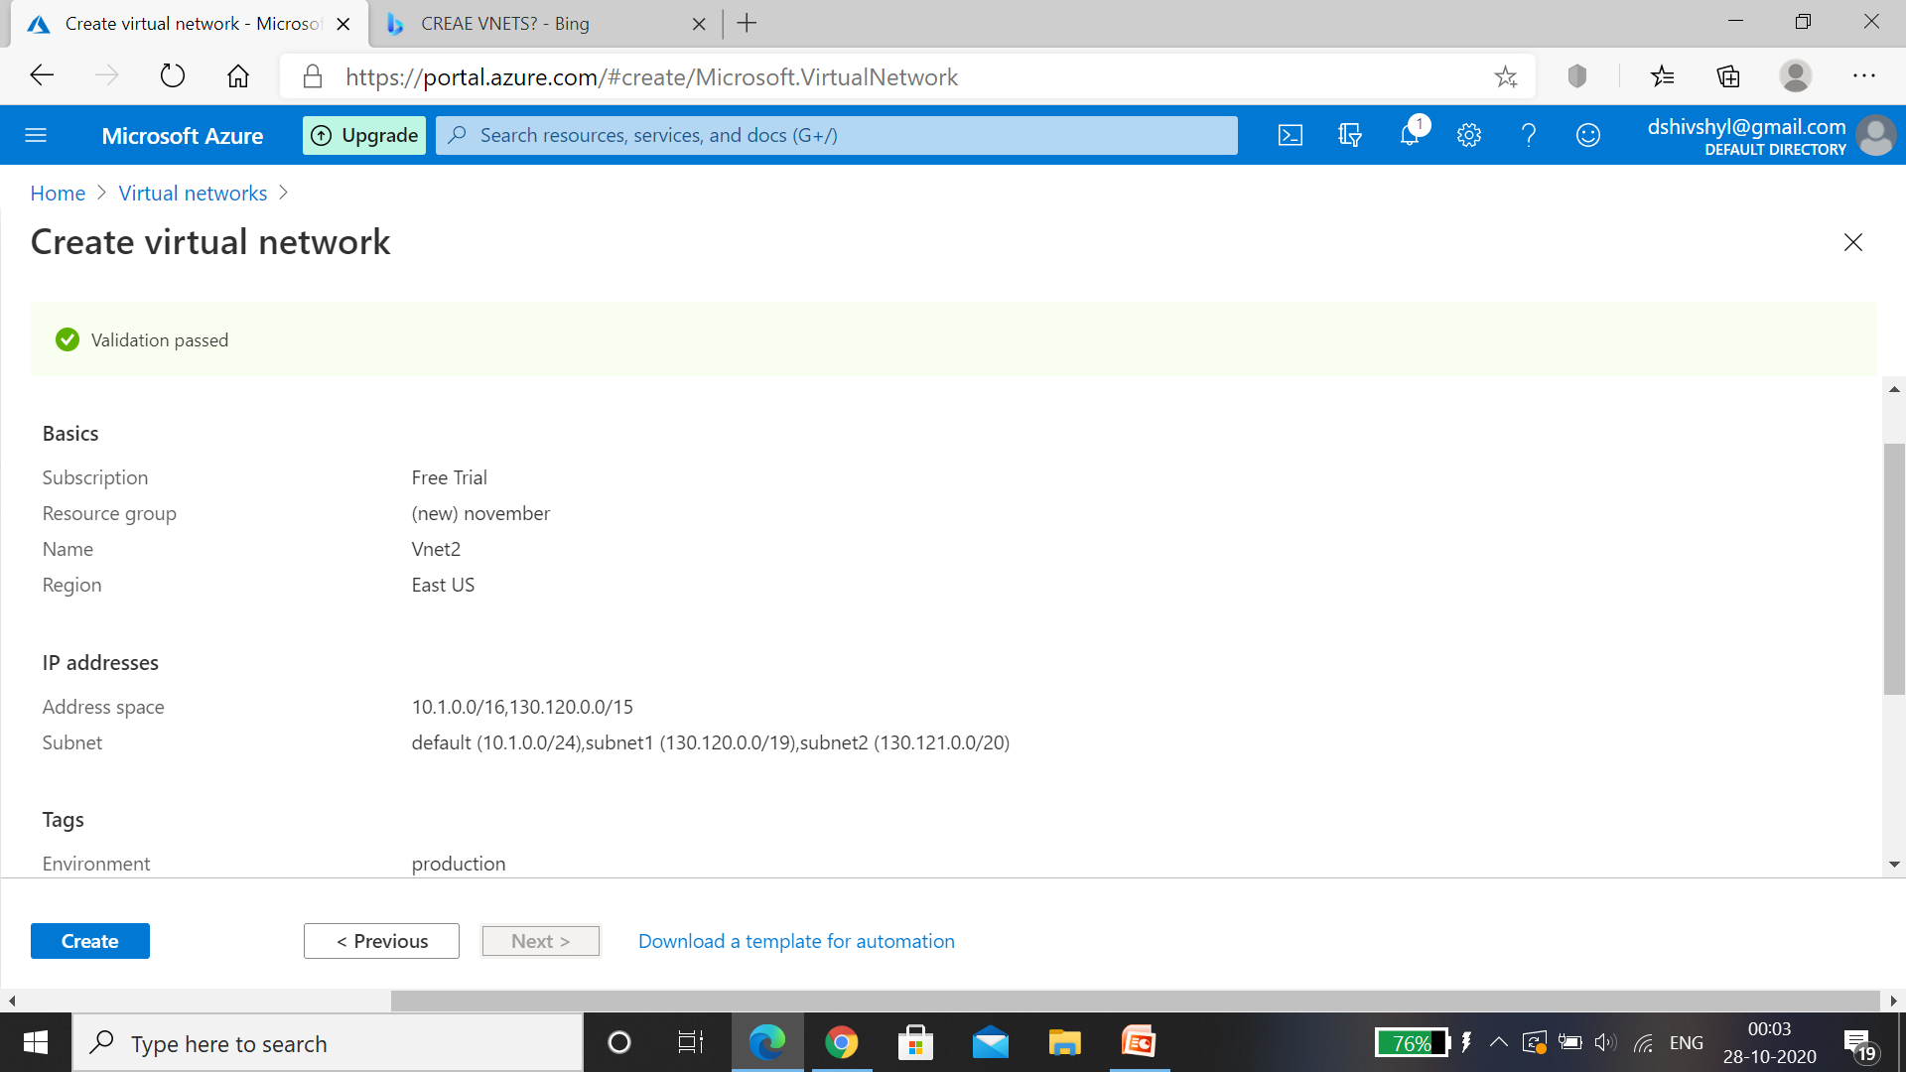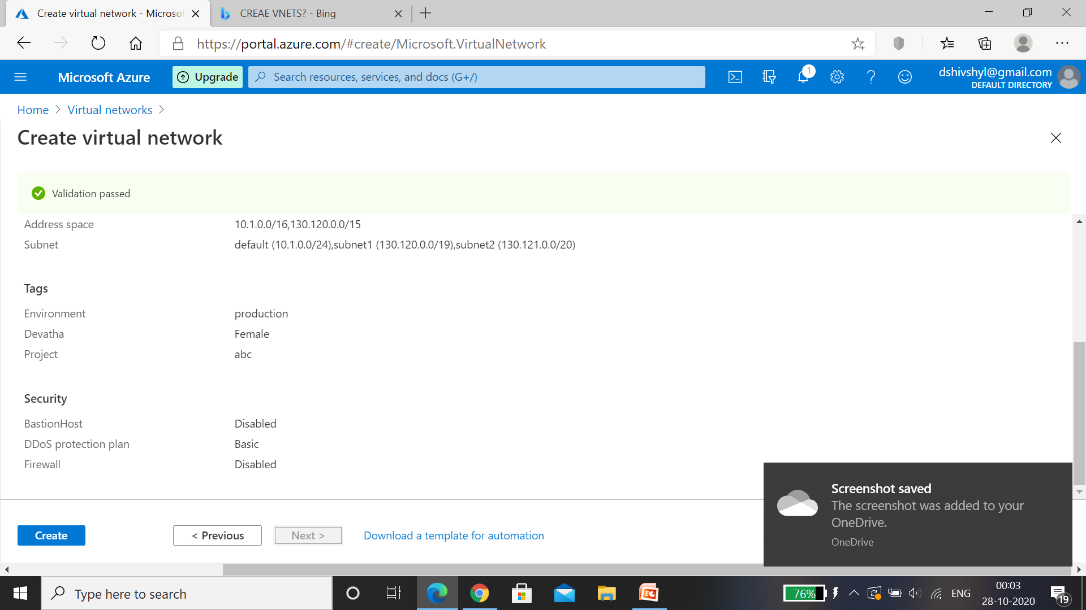

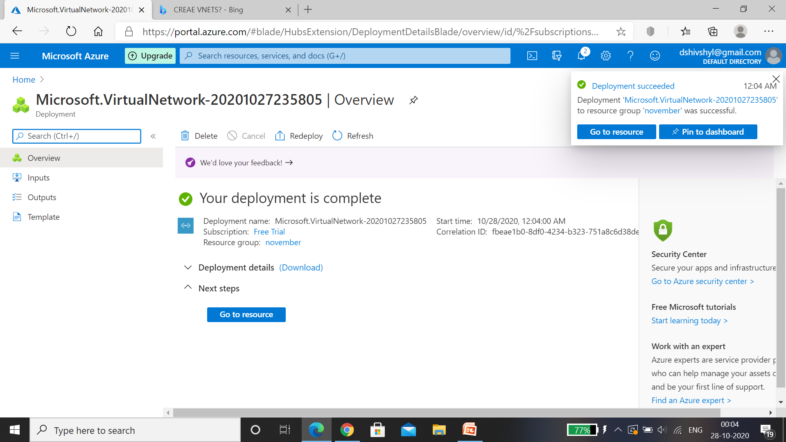

Step 16: Vnet 2 is created with 2 subnets.

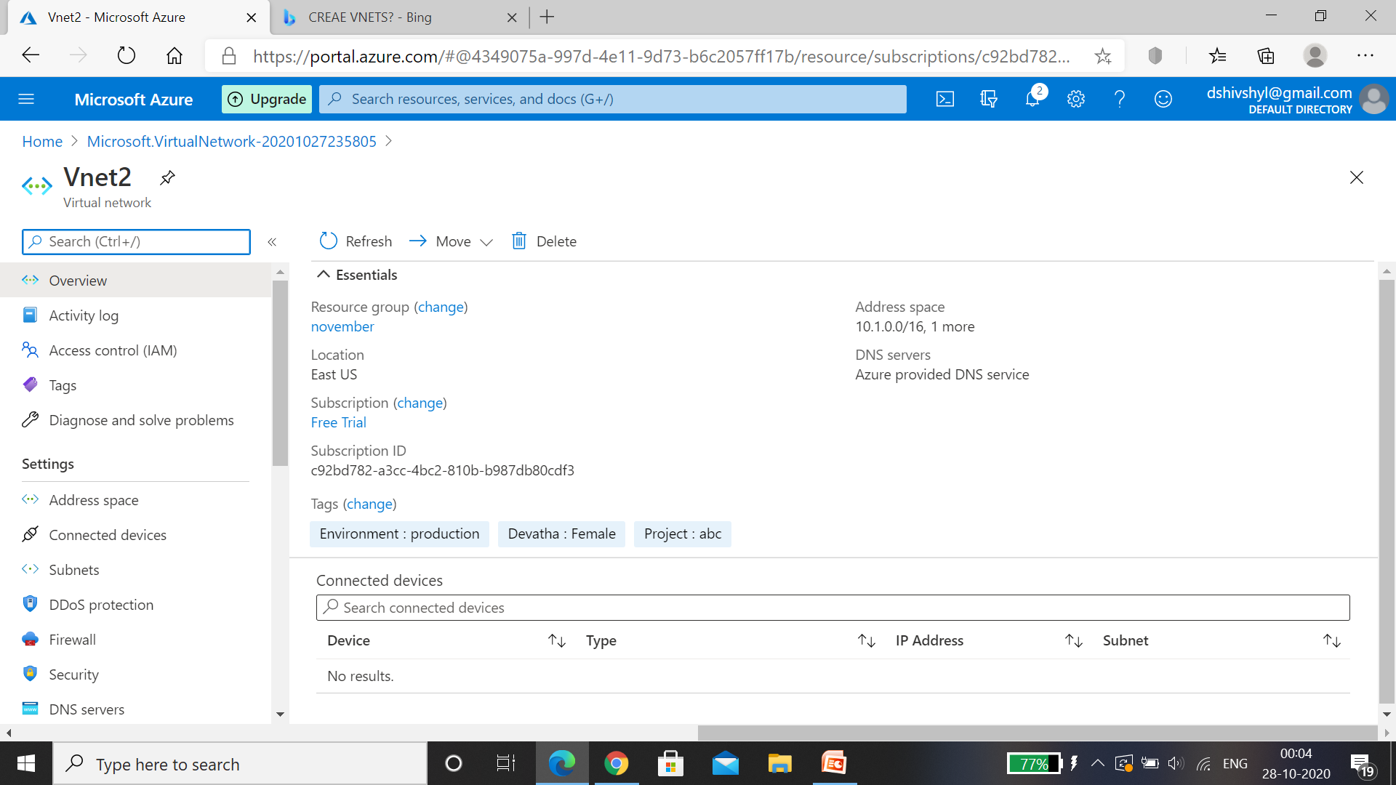

HENCE, 2 Vnets- Vnet1 and Vnet 2 are created with 2 Subsets in each Vnet’s.

# Create VM each Vnet1 and 2.

Virtual Machine: In computing, a virtual machine (VM) is an [emulation](https://en.wikipedia.org/wiki/Emulator) of a computer system. Virtual machines are based on [computer architectures](https://en.wikipedia.org/wiki/Computer_architectures) and provide functionality of a physical computer. Their implementations may involve specialized hardware, software, or a combination.

Step1: After creating virtual network as above steps, On azure portal click on Virtual machine and click on Add and select Virtual machines.

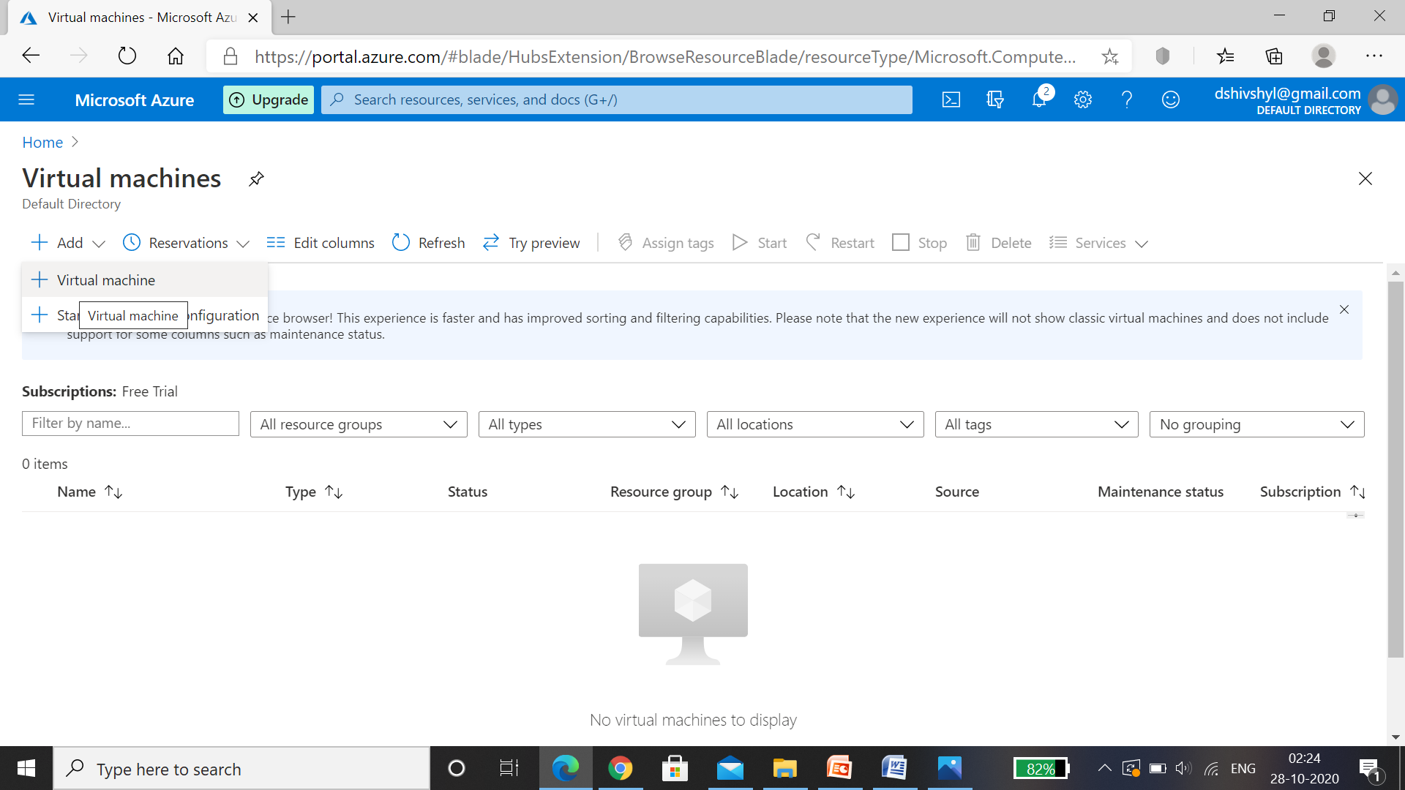

Step 2: Enter Basics details, Add resource group Vnet1 , In Instance details- Name the Virtual Machine as VM1, select the same region where virtual network is present so that in networking the machine can fetch the data default,select the image, select the size of the disk as per required, then Enter Administrator account details and then select inbound ports as RDP(3389)> Select Next:Disks.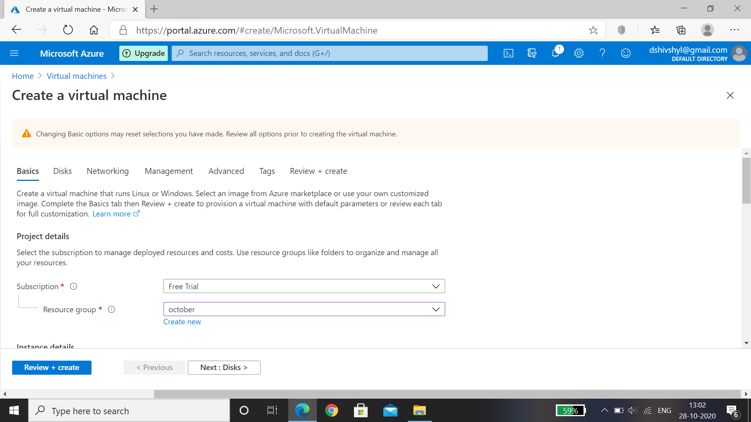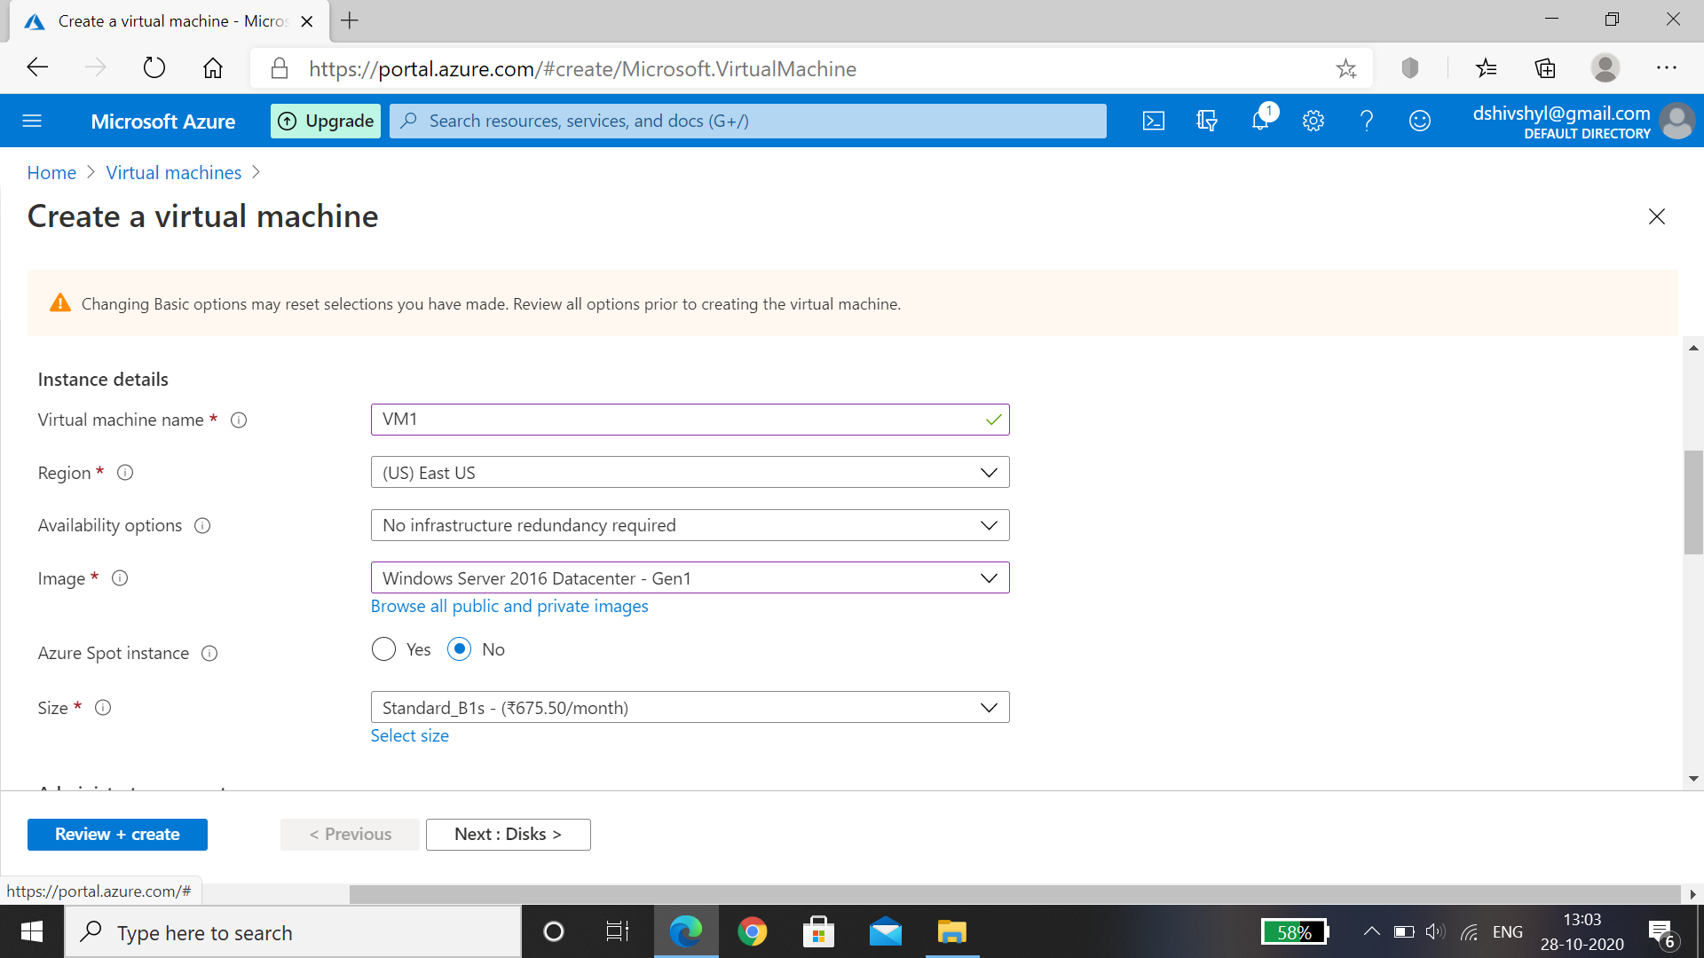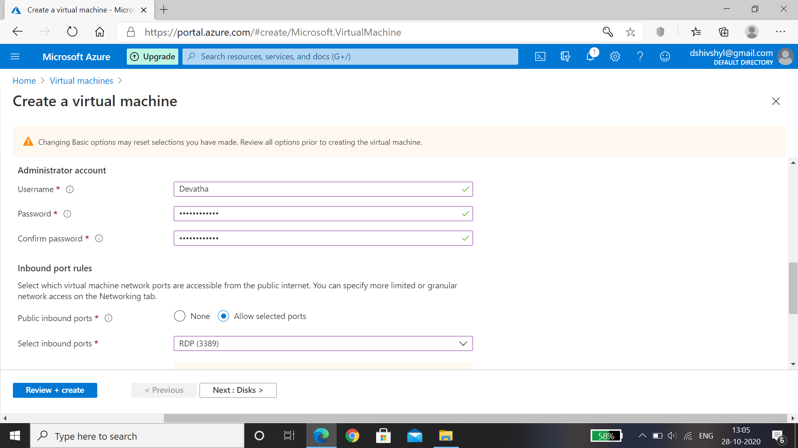

Step 3: Select OS Disk type as Premium SSD , Encryption type as default , select Next: Networking. 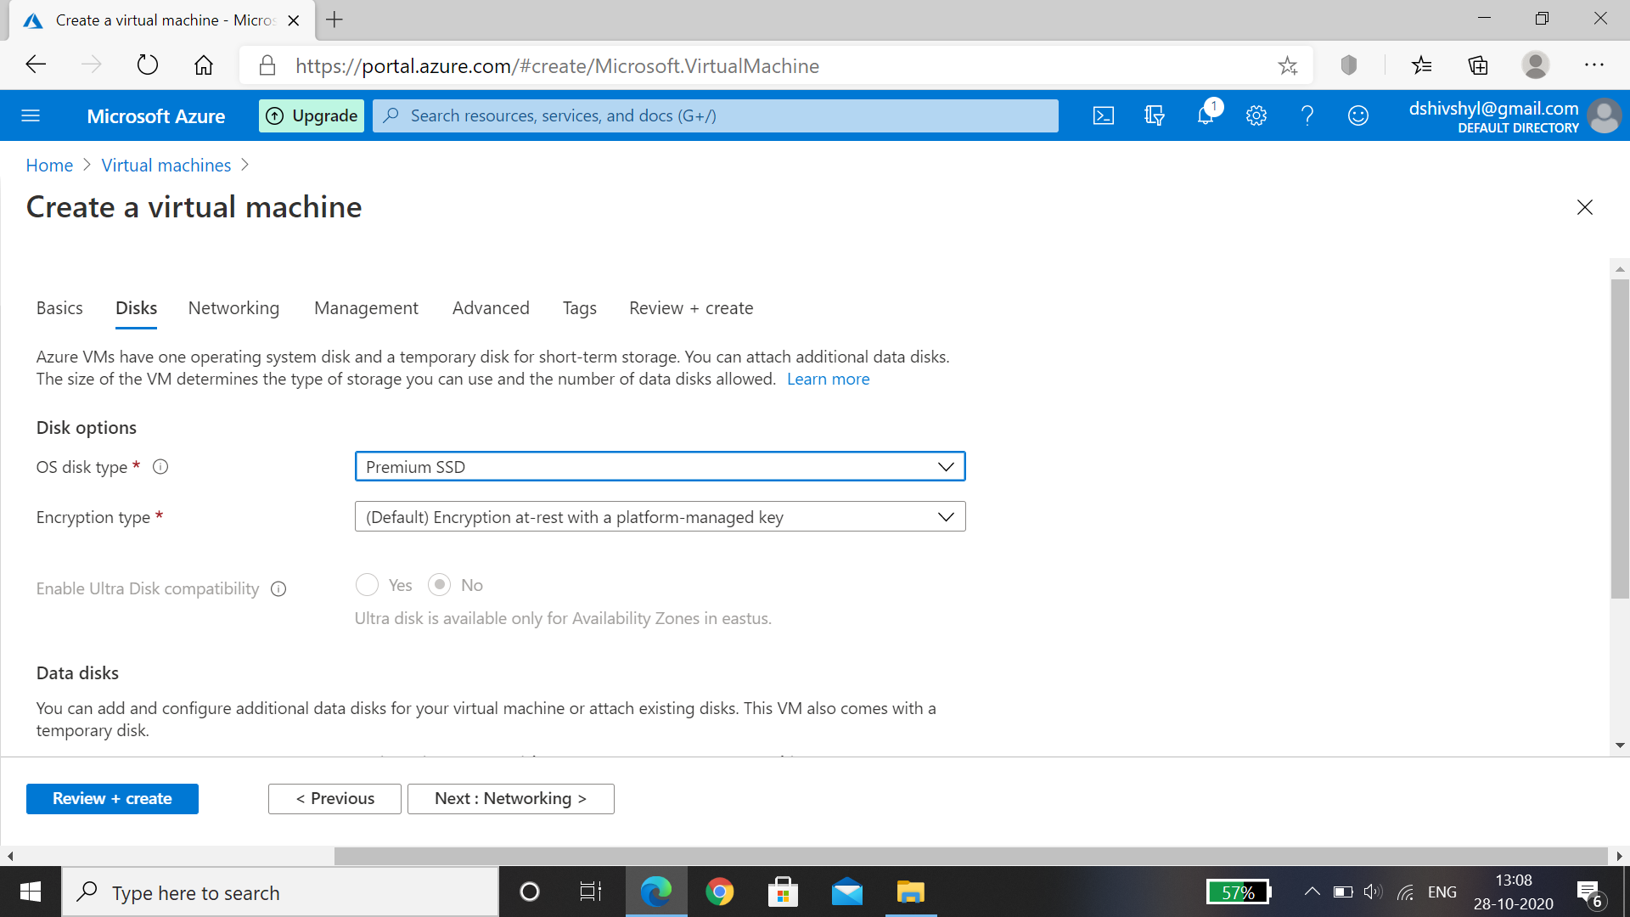

Step 4: In Networking , Virtual network name is taken default , subnet is default , change Public IP address to pip01,select inbound ports as RDP(3389) for windows machine. Then click on Next:Management.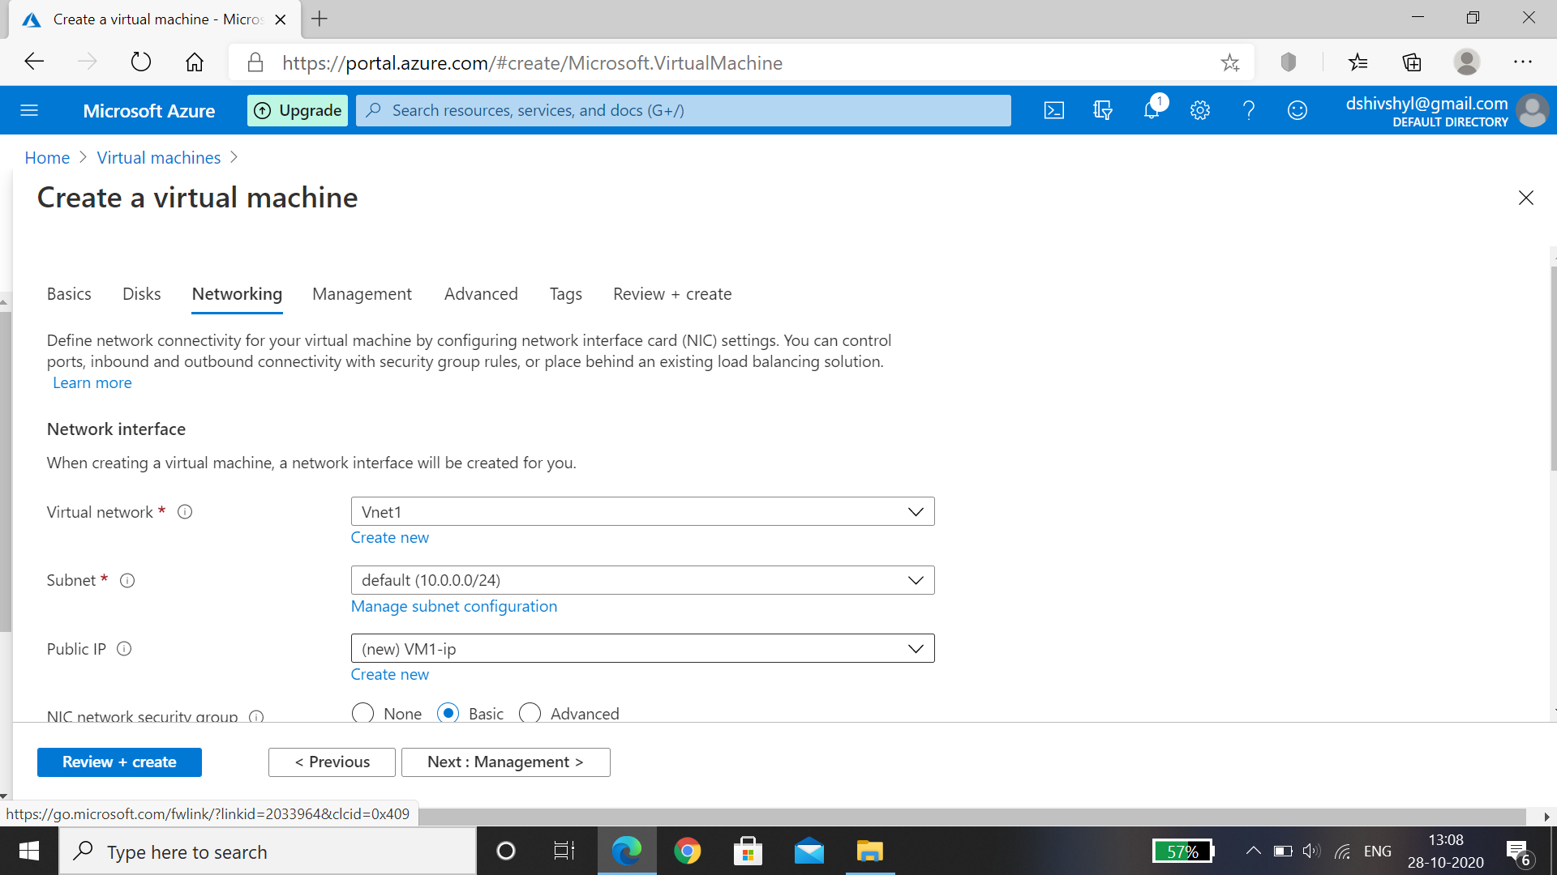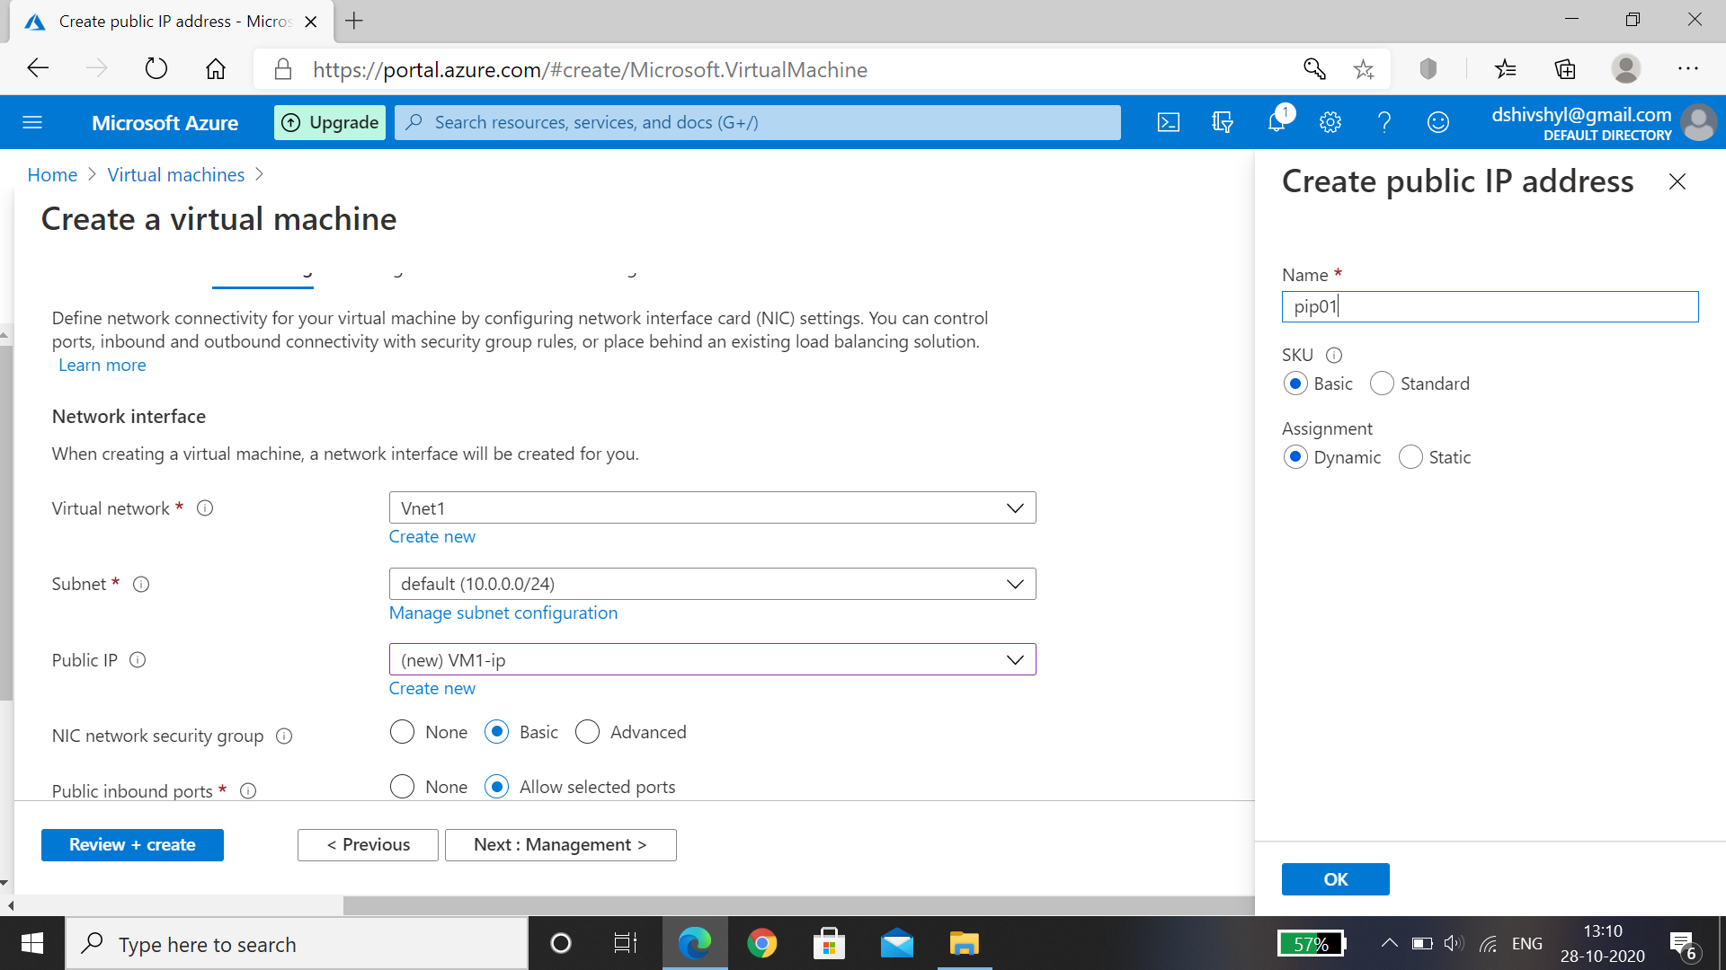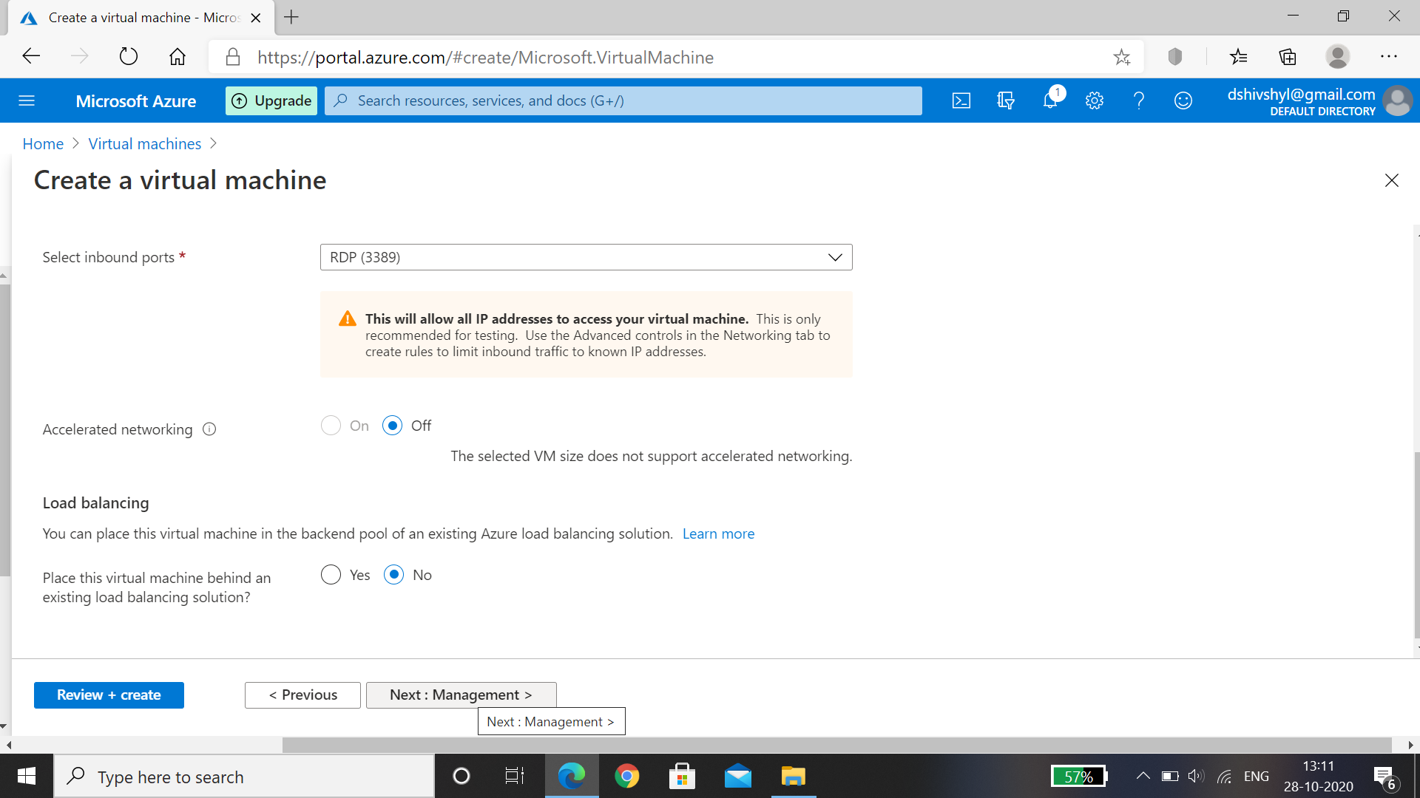

Step 5: Management , enable basic plan for free , let all default and then click on Next:Advanced.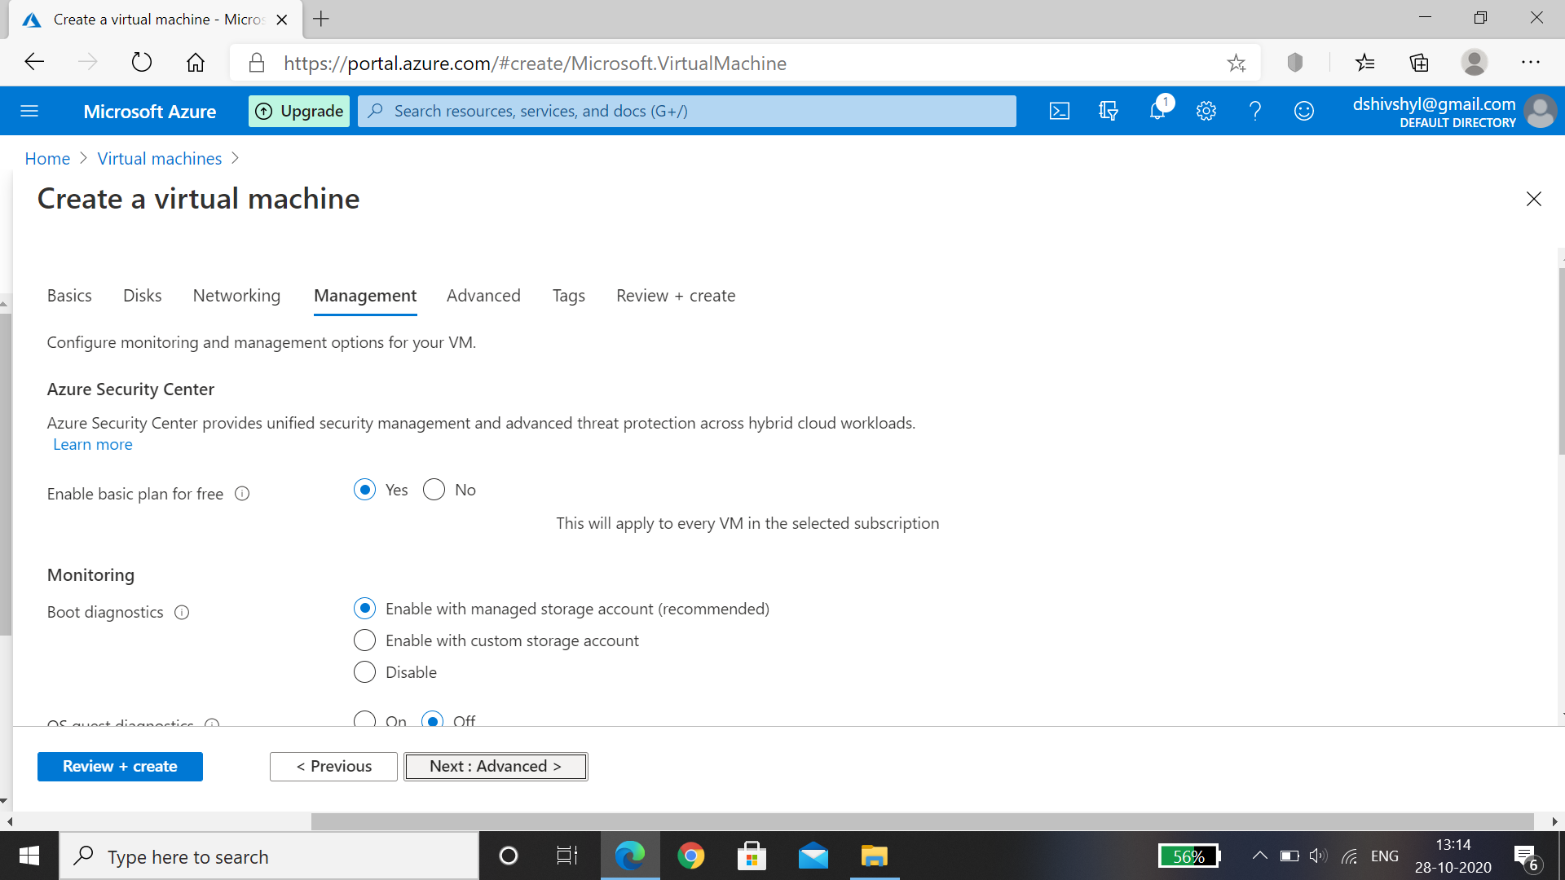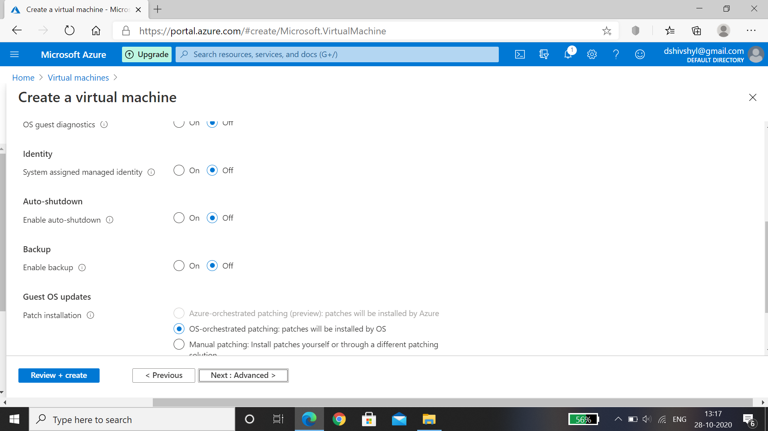

Step 6: in extensions we can find anti virus softwars, post and proximately group is based on host group as we don’t have now, In VM Generation select Gen1. Select Next: Tags. 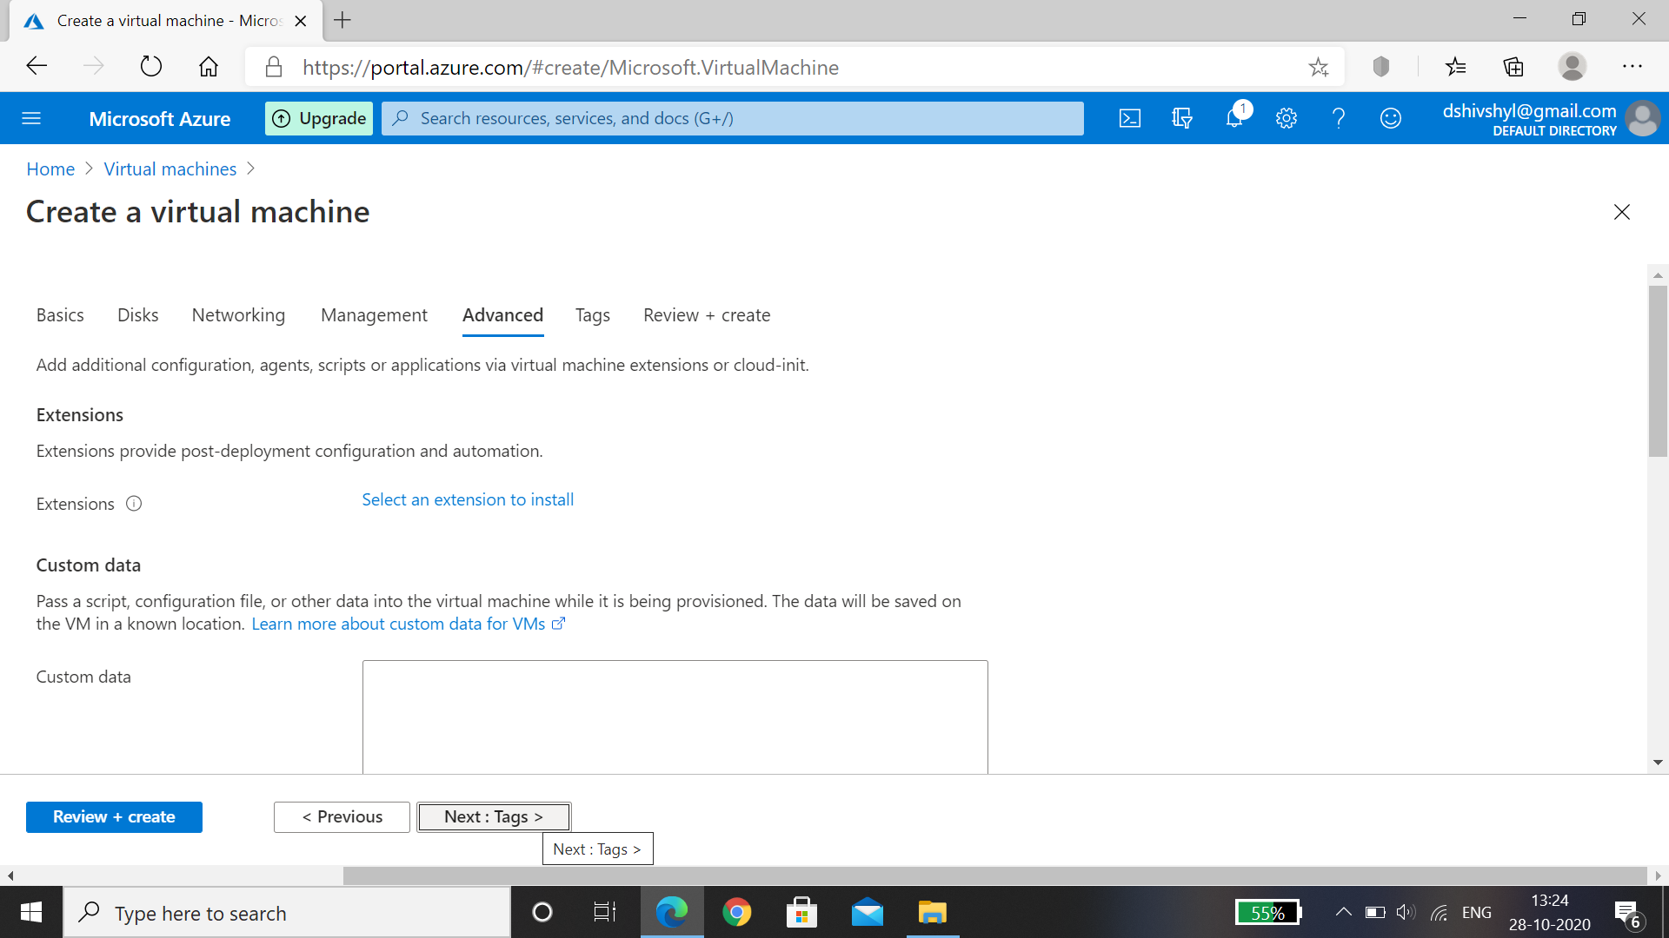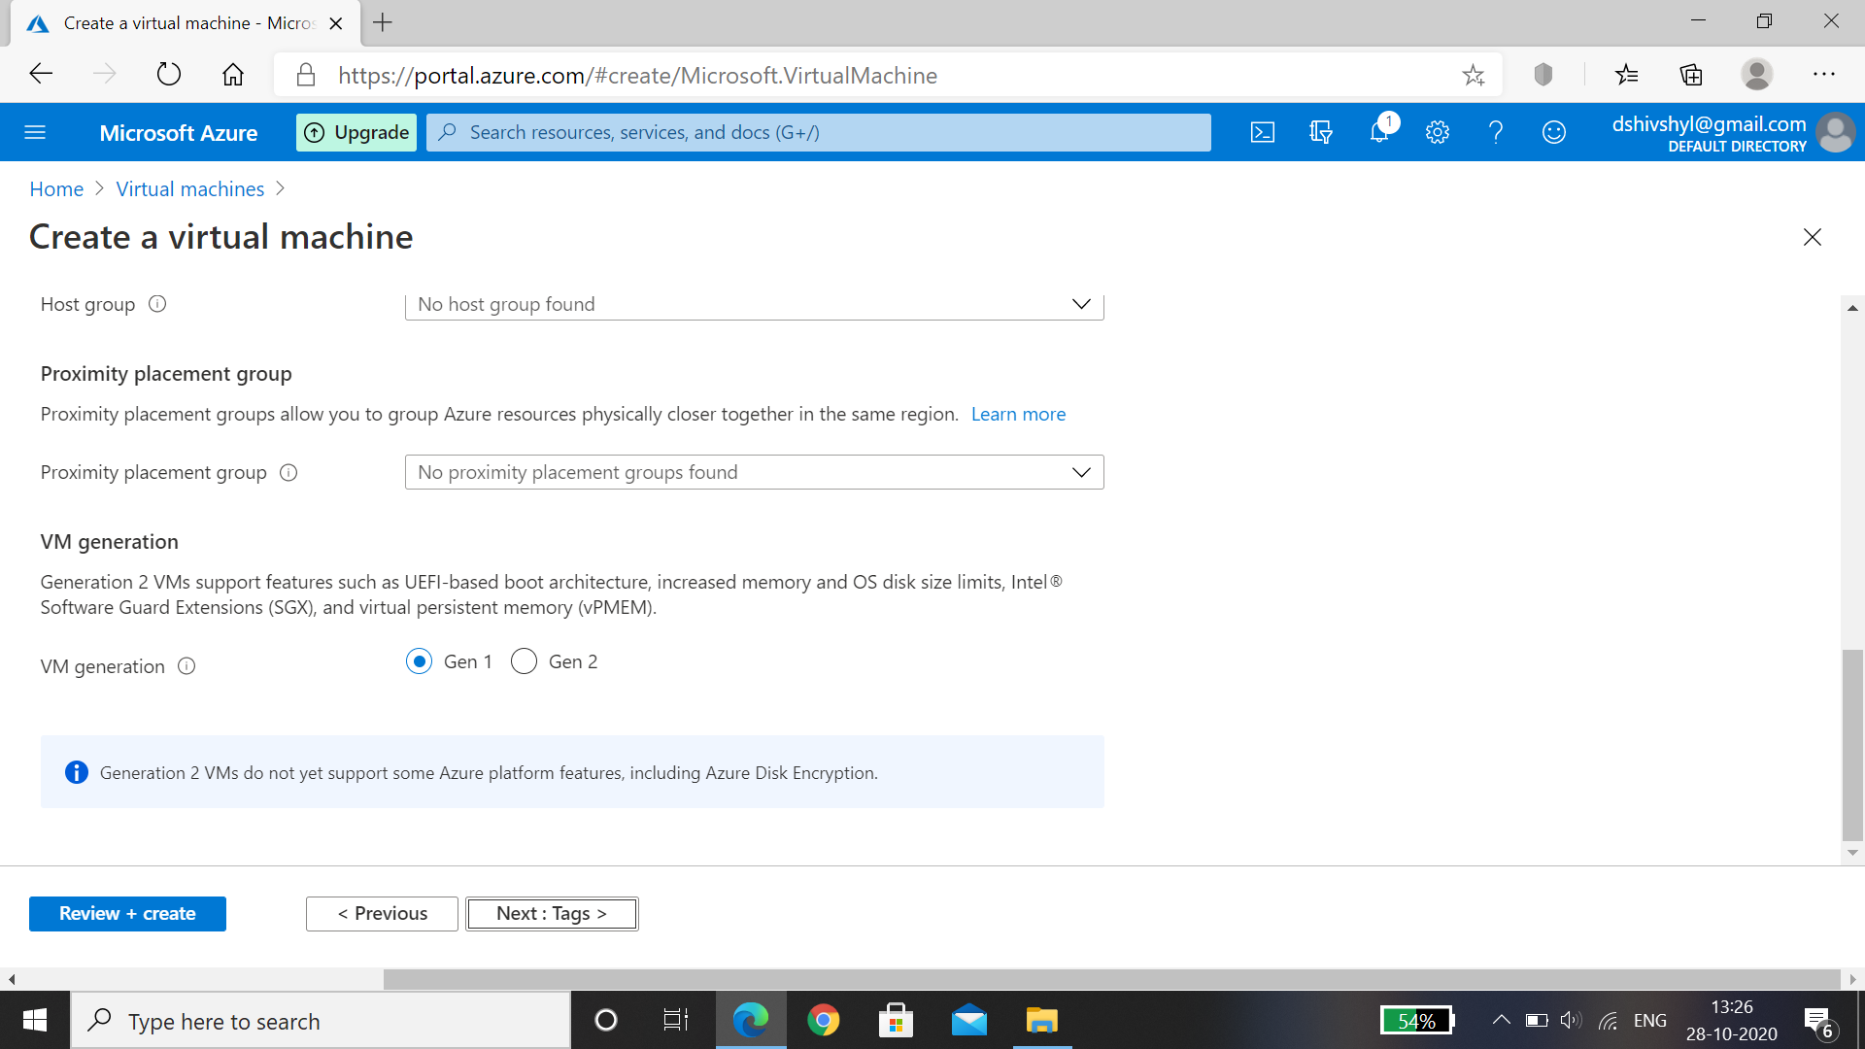

Step 7: Add all the resource data ,click on Review+ Create , wait for the validation passed later select Create, after deployment is complete select Go to resource.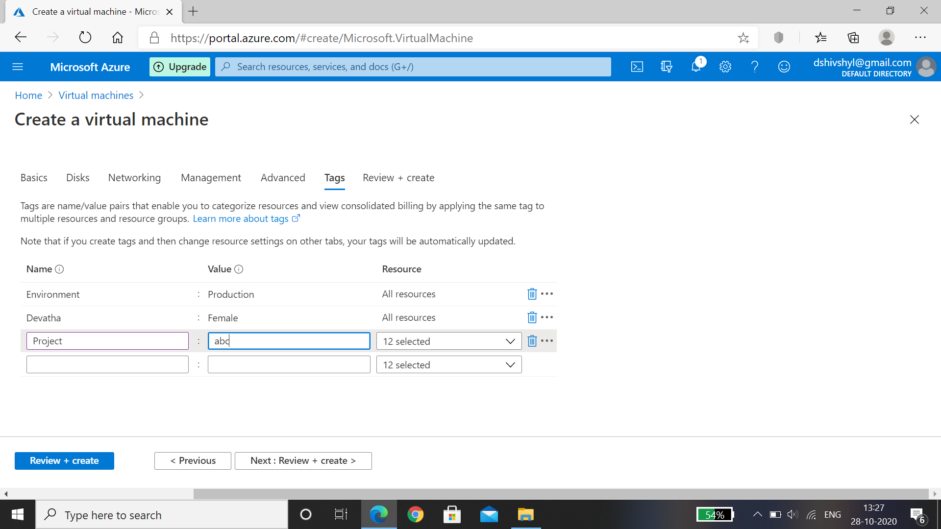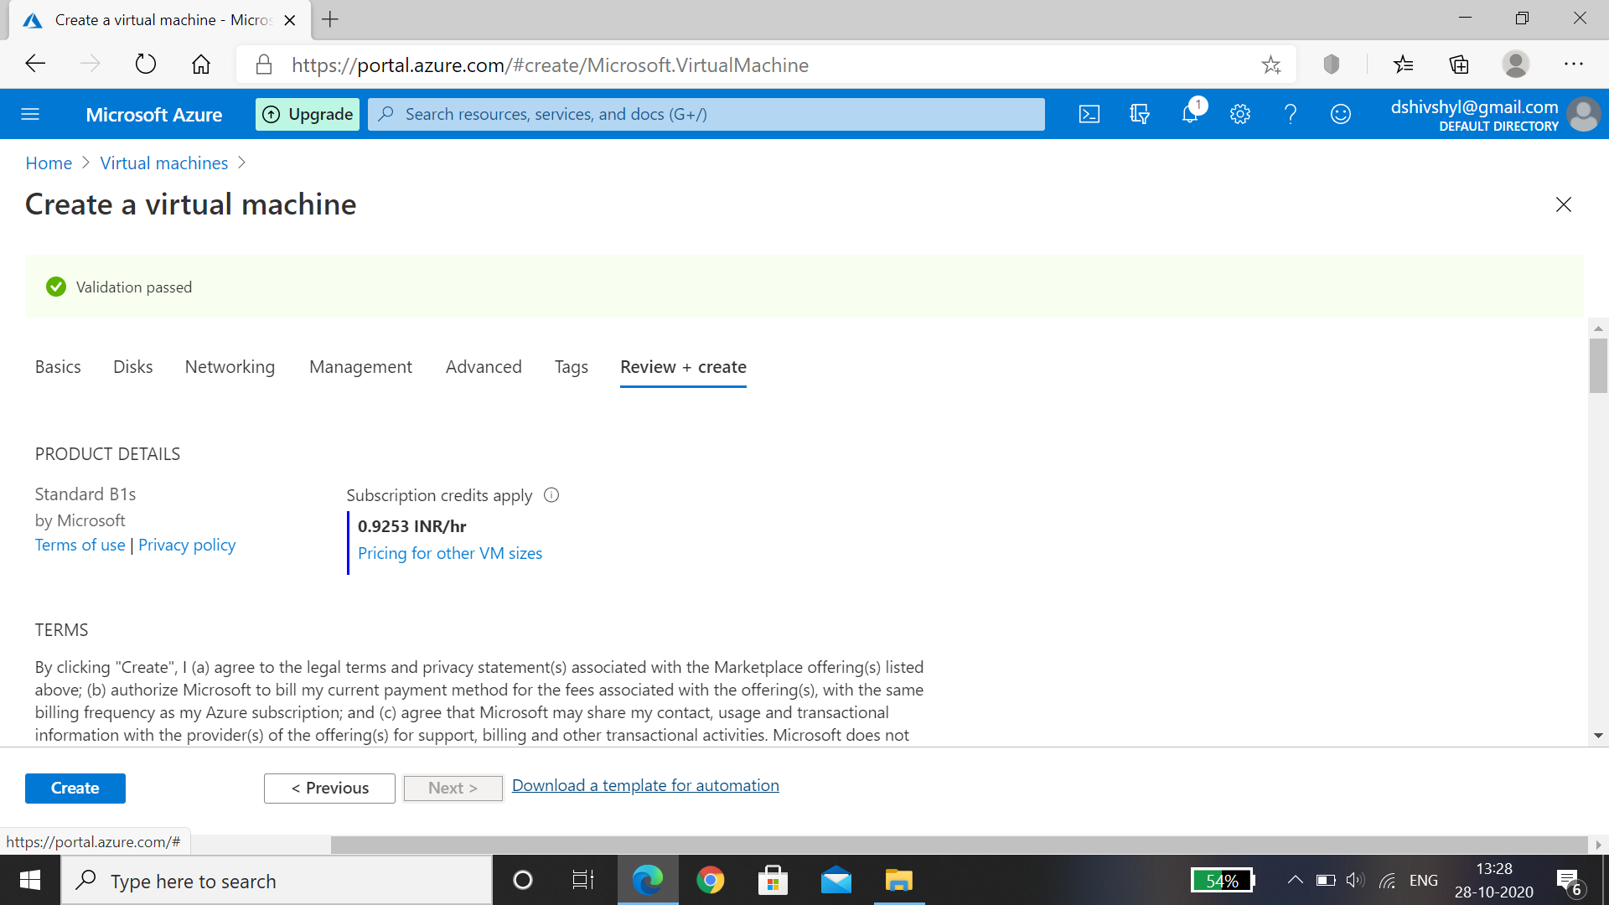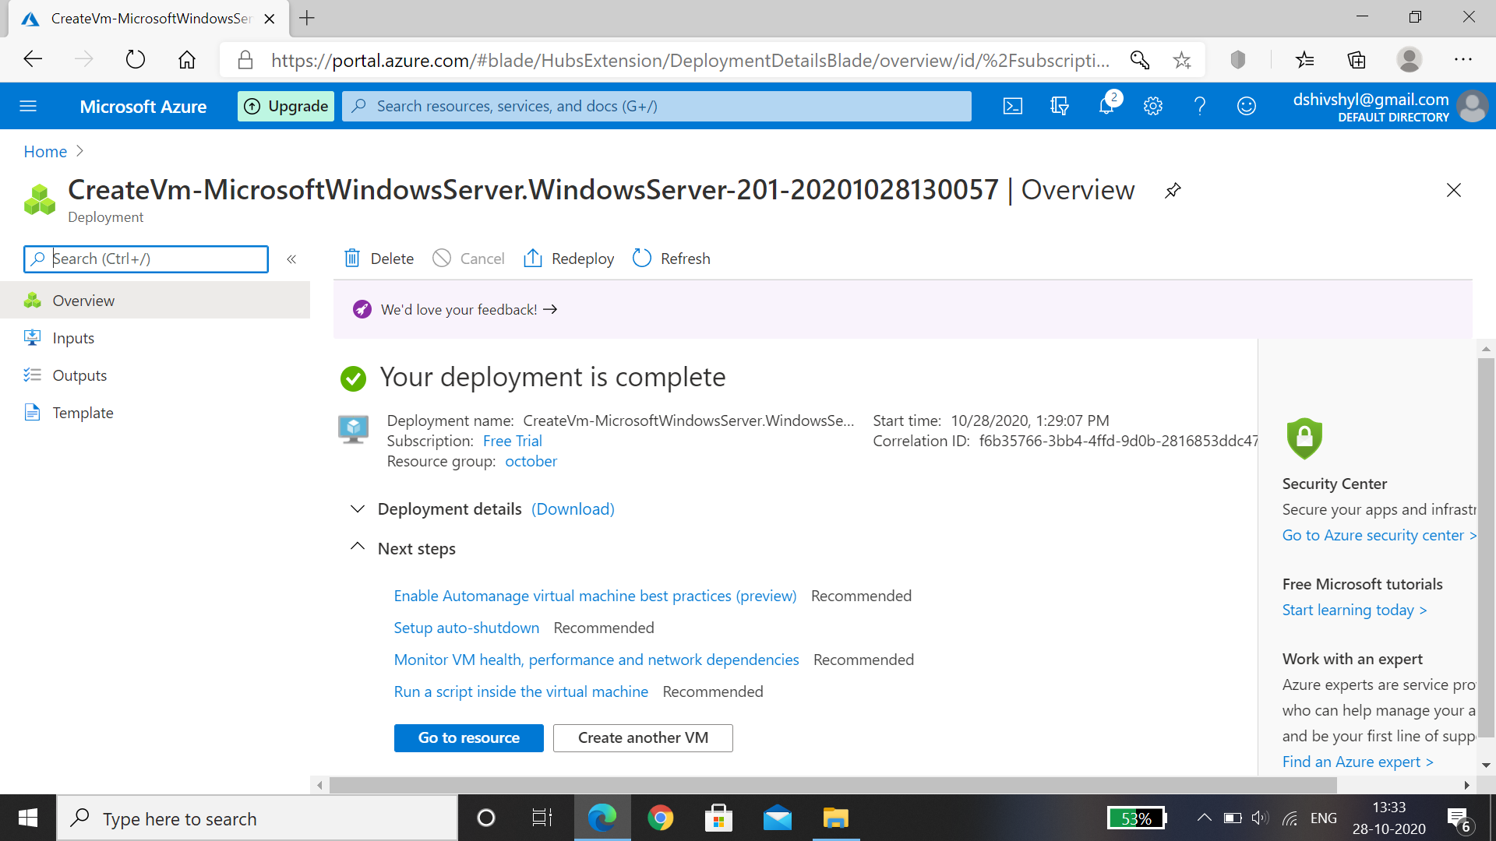

Step 9: VM1 is created.

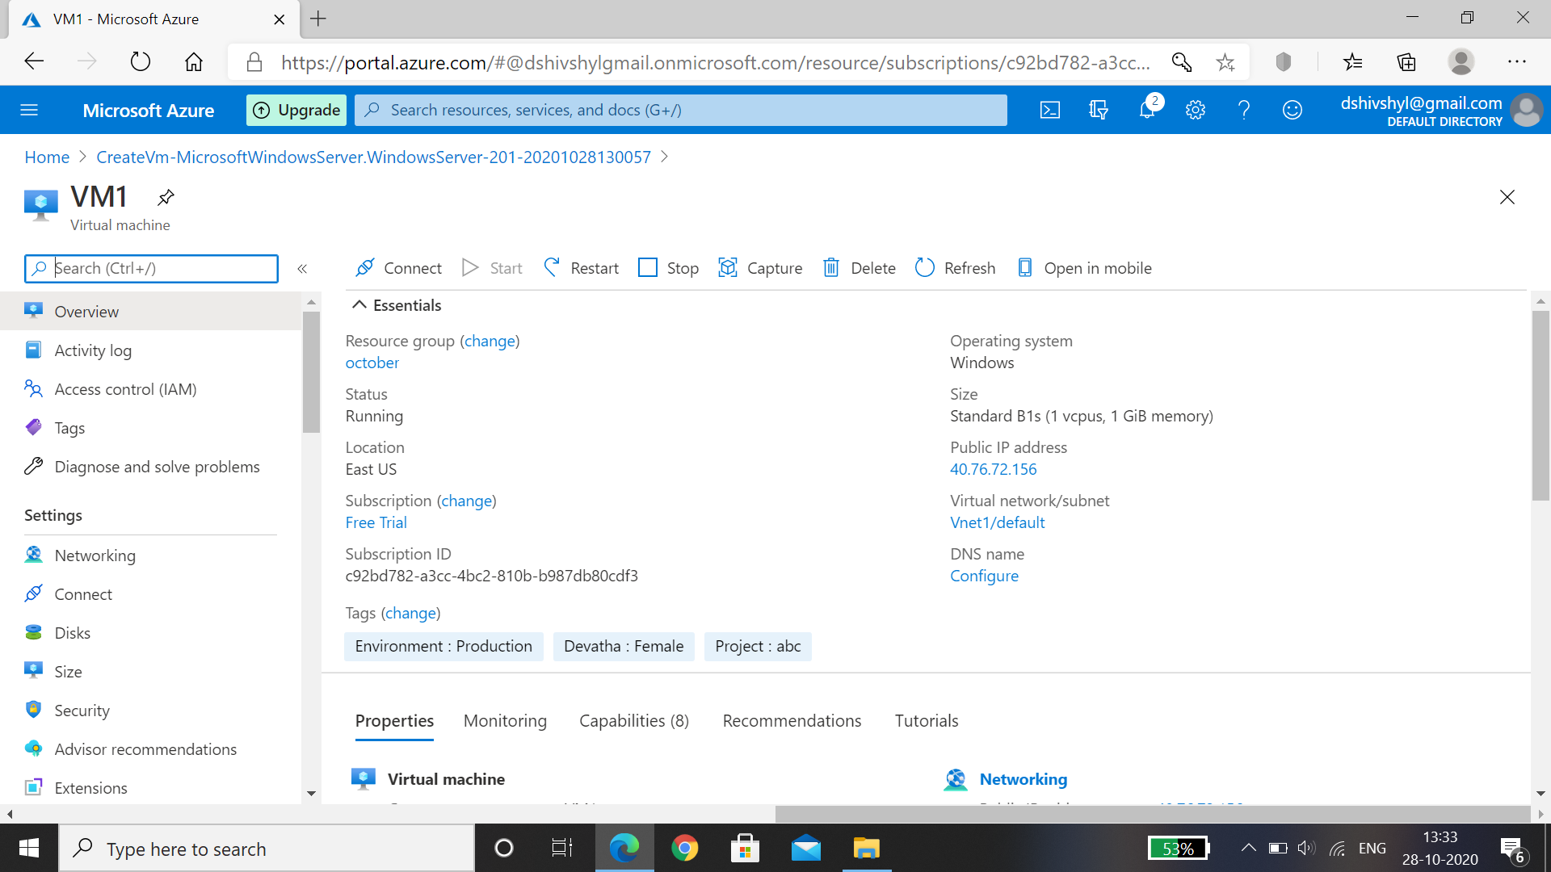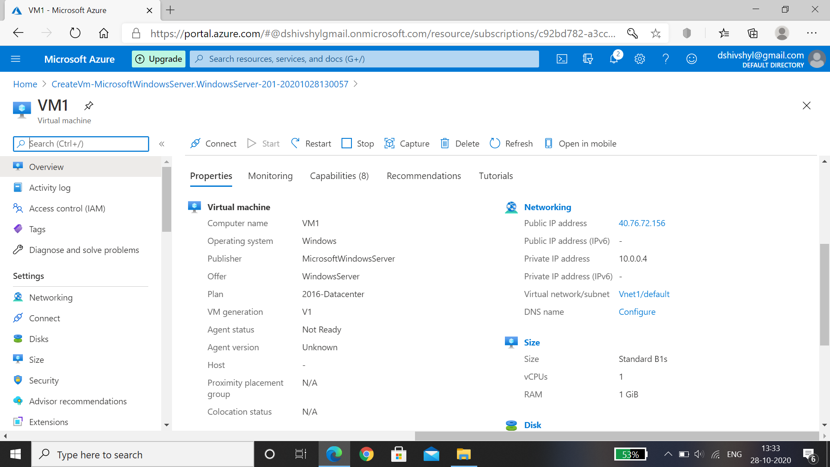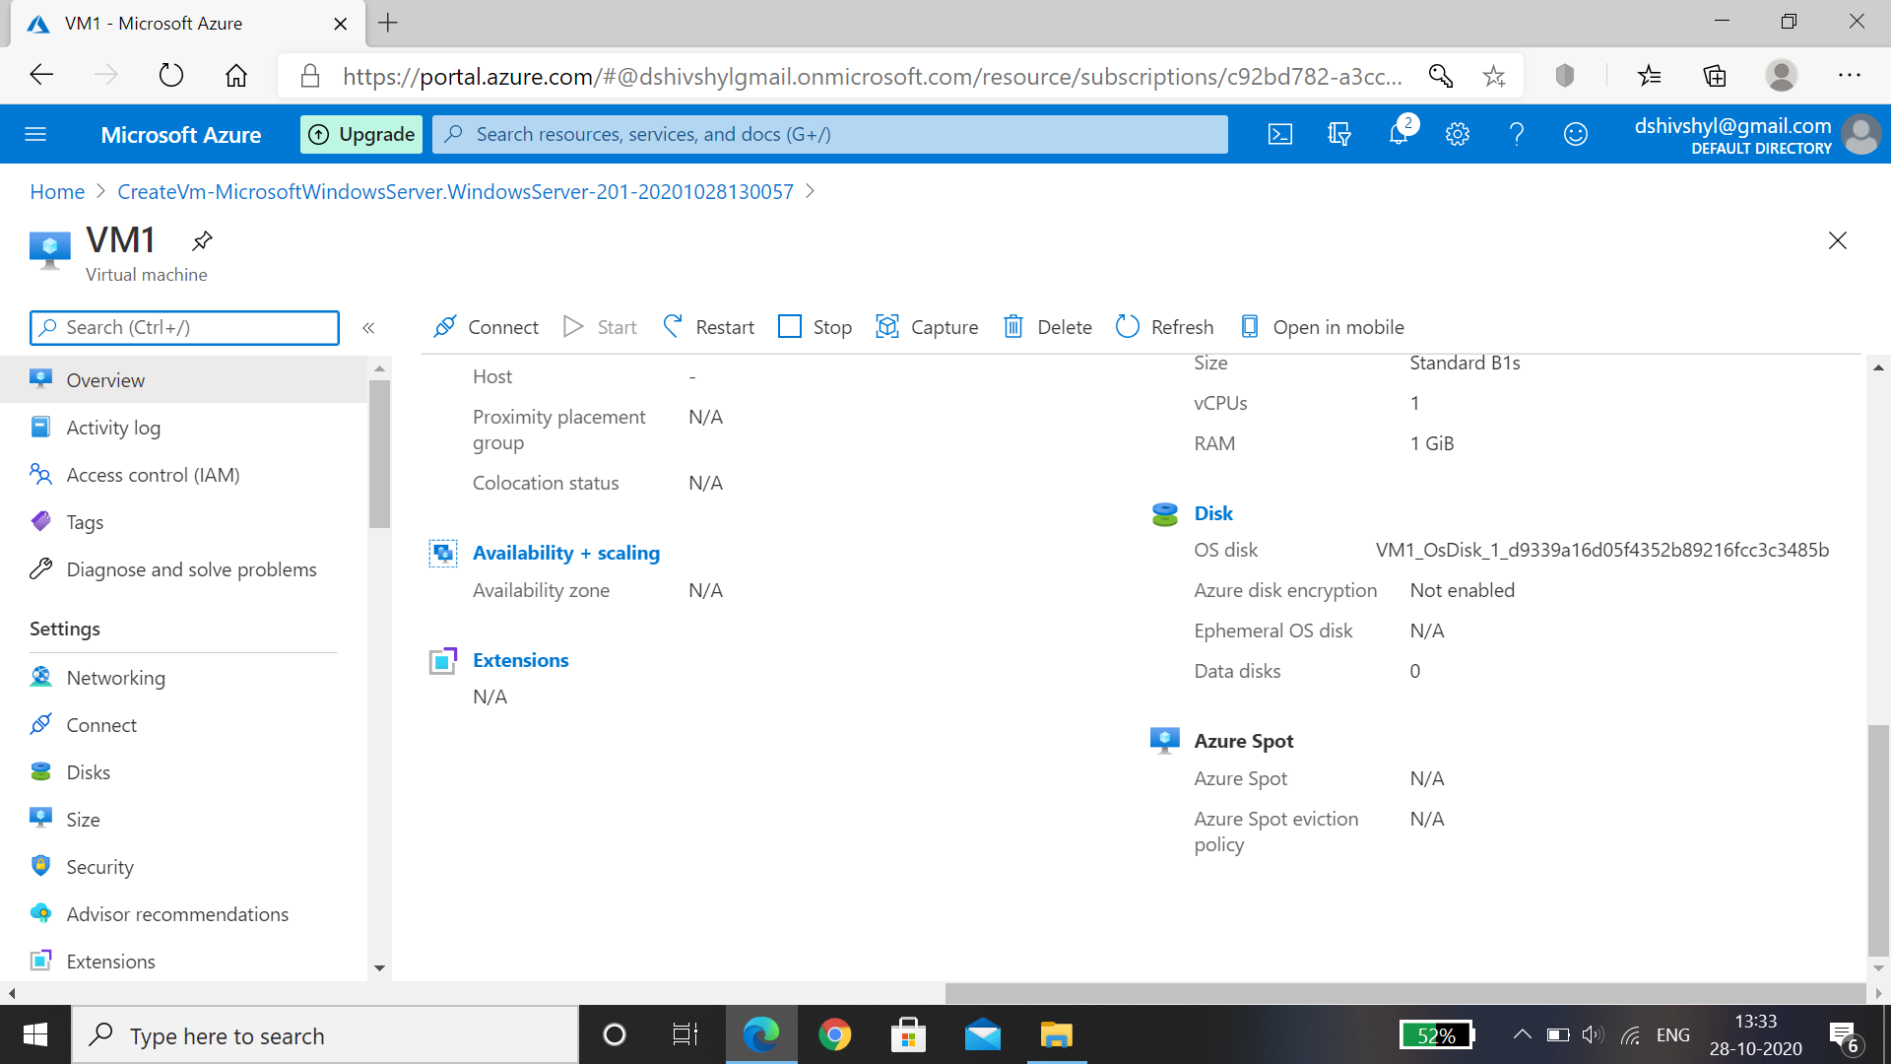

Hence VM1 is created for the Resource Vnet1.

For creating VM2 form the resource group Vnet2 .

Step10: After creating virtual network Vnet2 , On azure portal click on Virtual machine and click on Add and select Virtual machines.



Step 11: Enter Basics details, Add resource group Vnet2, In Instance details- Name the Virtual Machine as VM2, select the same region where virtual network is present so that in networking the machine can fetch the data default,select the image, select the size of the disk as per required, then Enter Administrator account details and then select inbound ports as RDP(3389)> Select Next:Disks

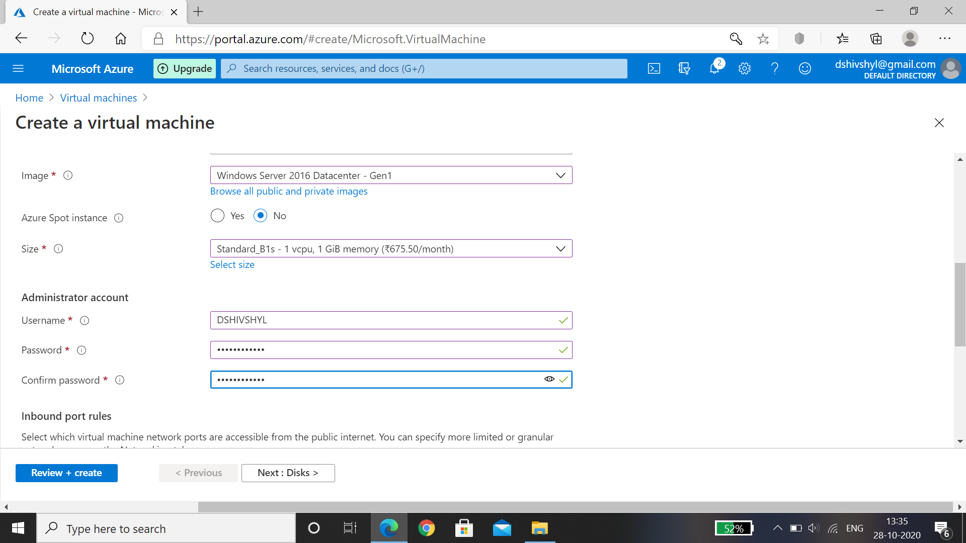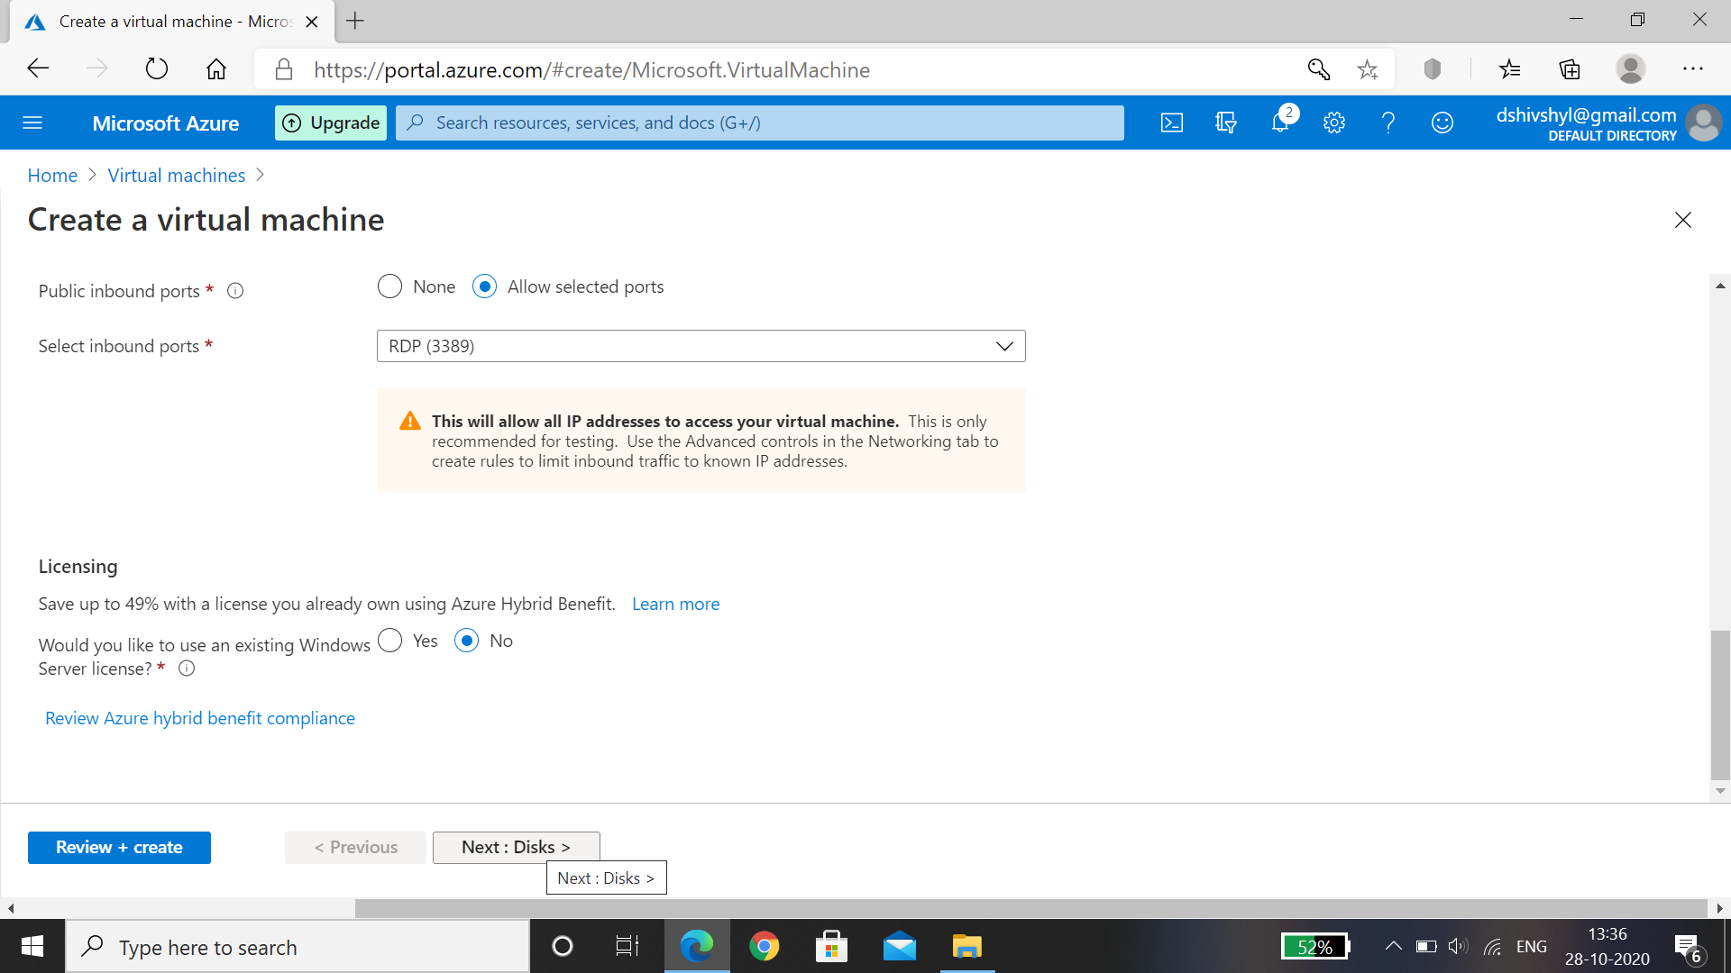

Step 12: Select OS Disk type as Premium SSD , Encryption type as default , select Next: Networking.

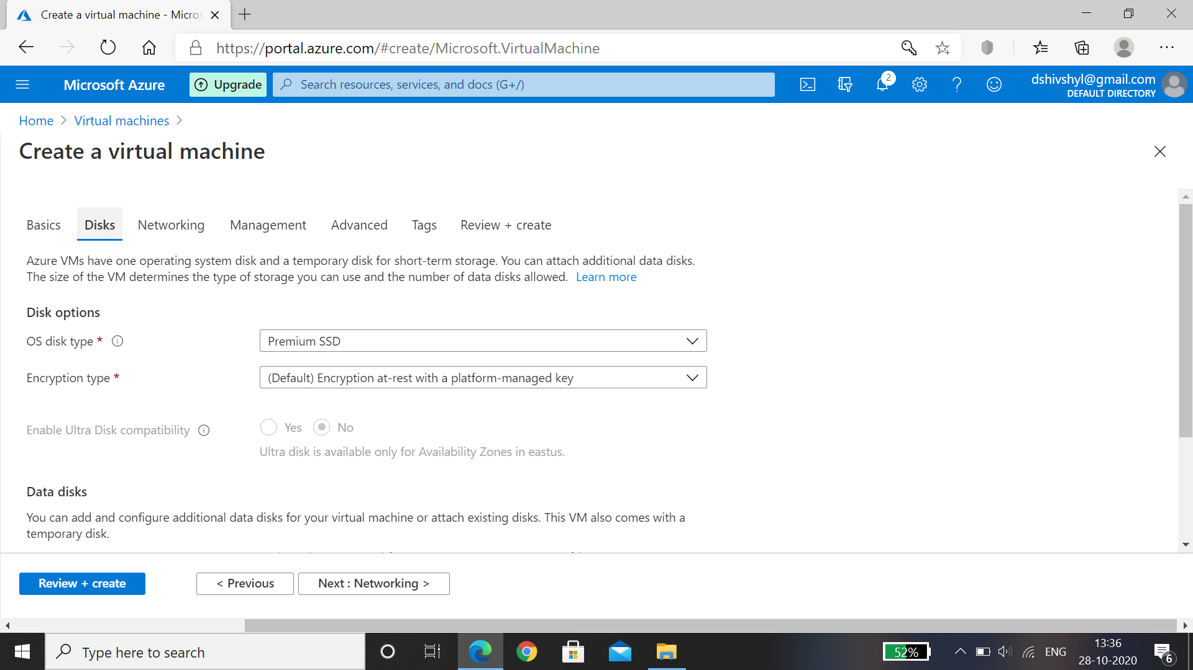

Step 13: In Networking , Virtual network name is taken default , subnet is default ,select inbound ports as RDP(3389) for windows machine. Then click on Next:Management.

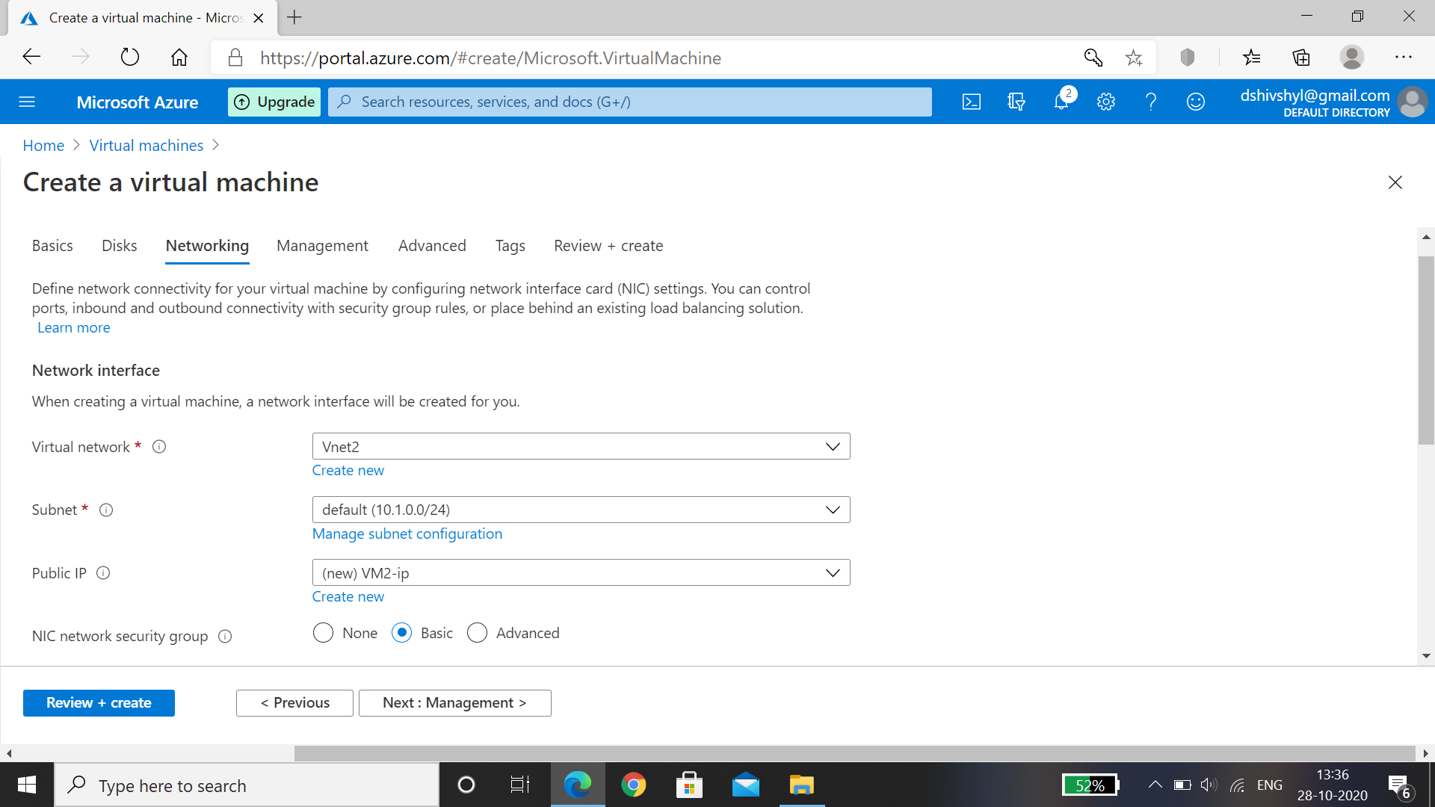

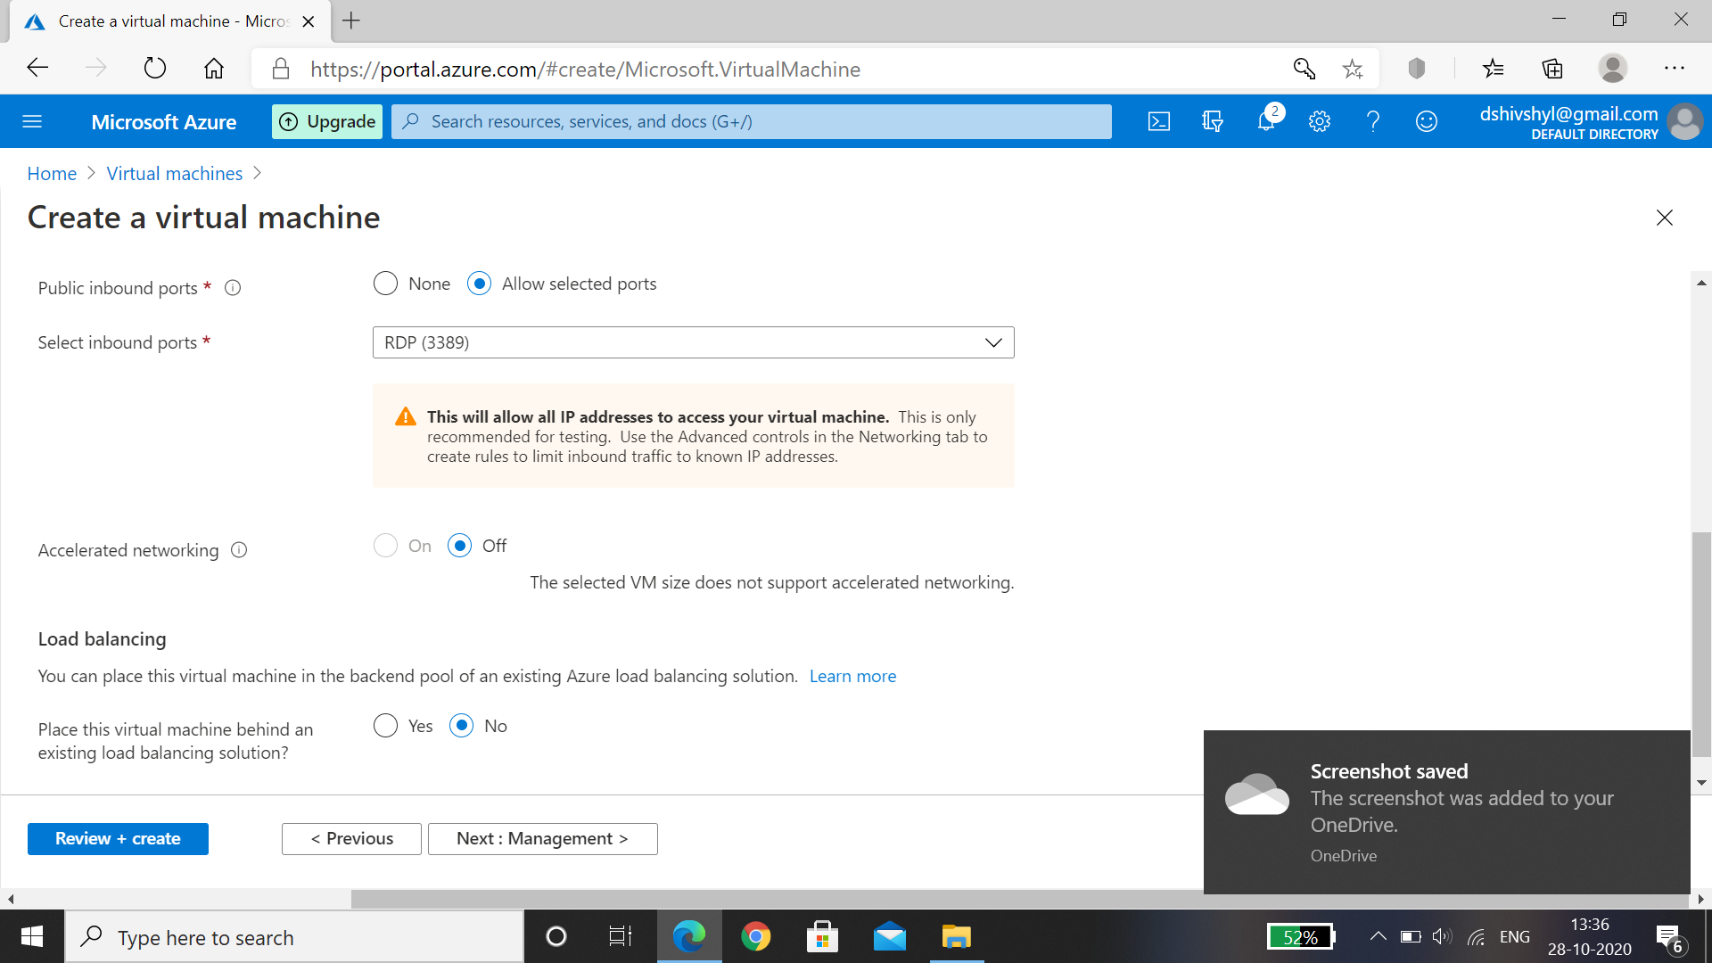

Step 14: Management , enable basic plan for free , let all default and then click on Next: Advanced.

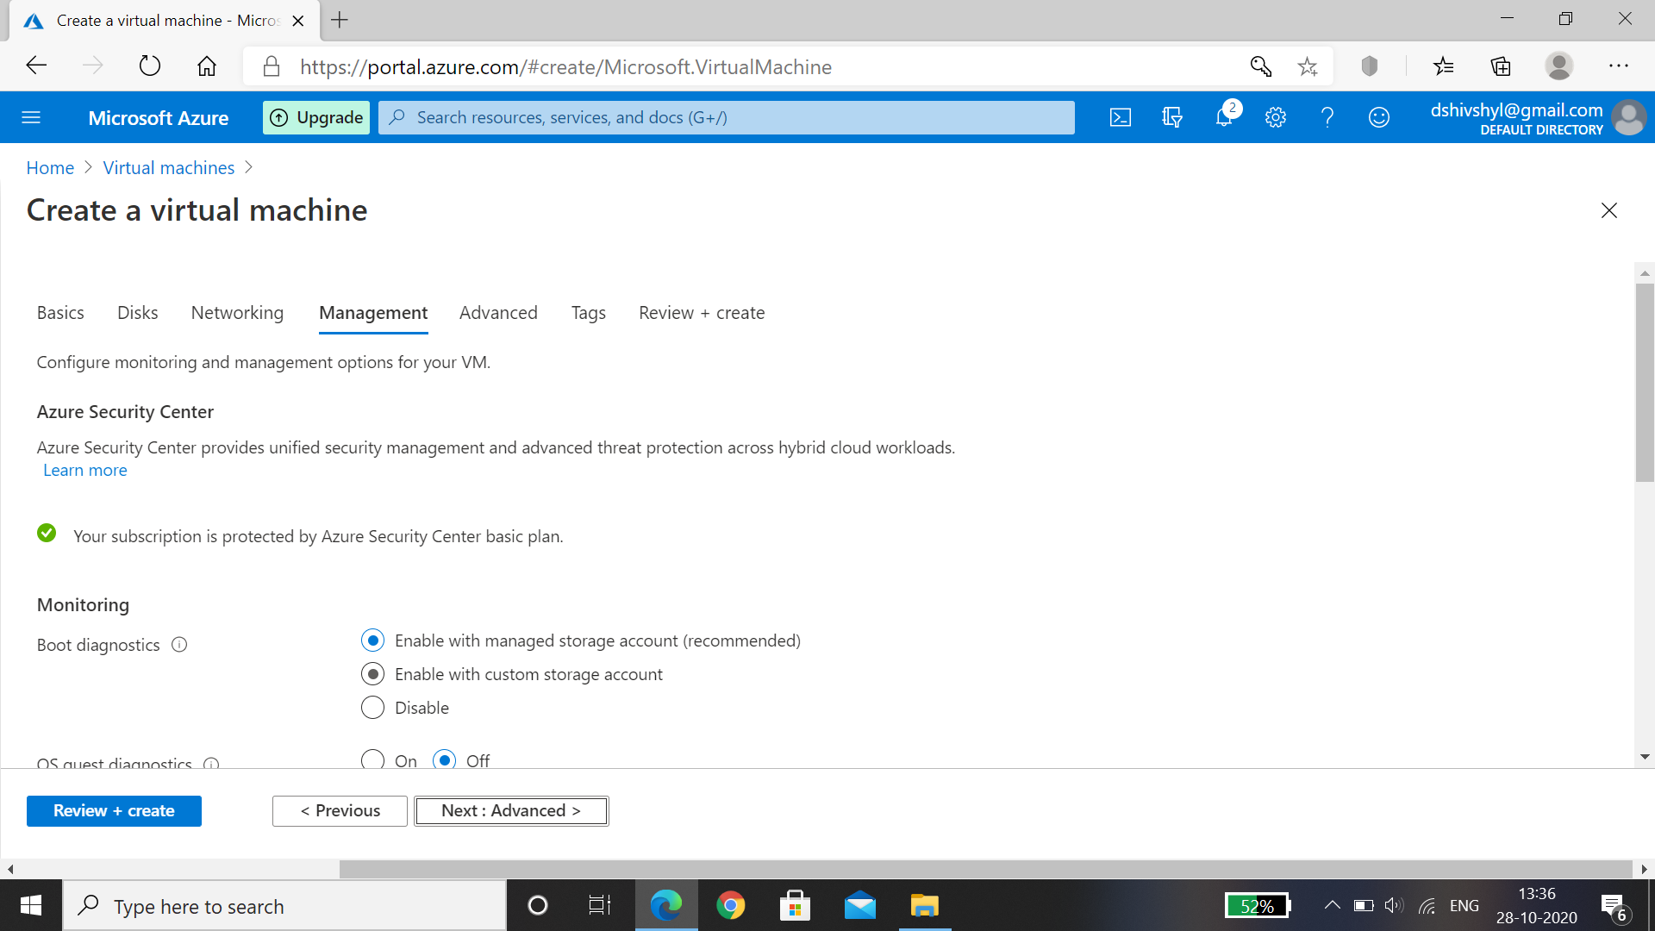

Step 15: in extensions we can find anti-virus software, post and proximately group is based on host group as we don’t have now, In VM Generation select Gen1. Select Next: Tags.

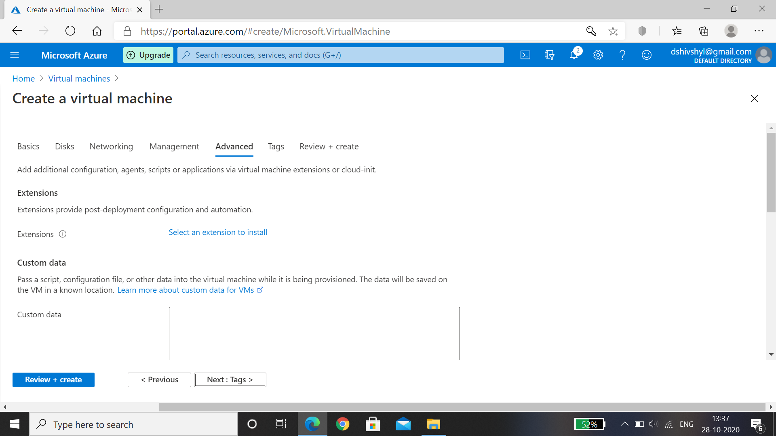

Step 16: Add all the resource data ,click on Review+ Create , wait for the validation passed later select Create, after deployment is complete select Go to resource

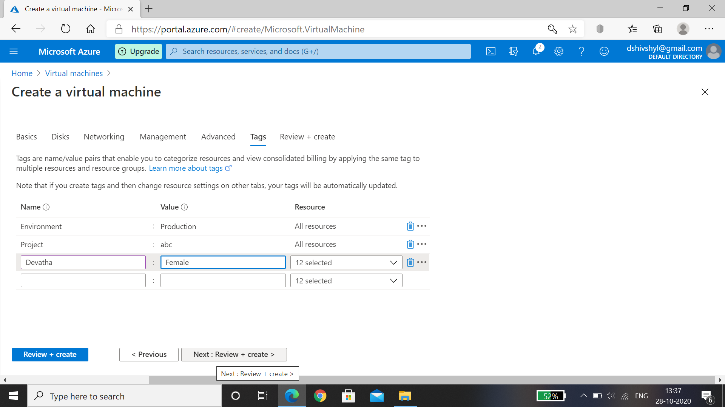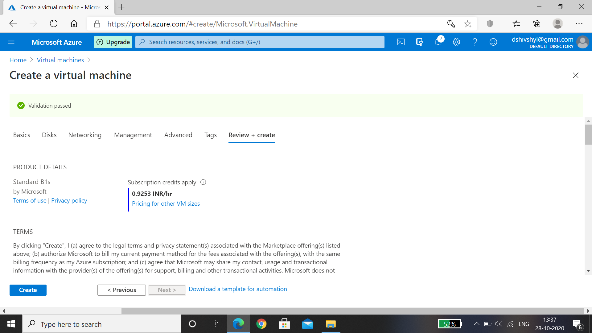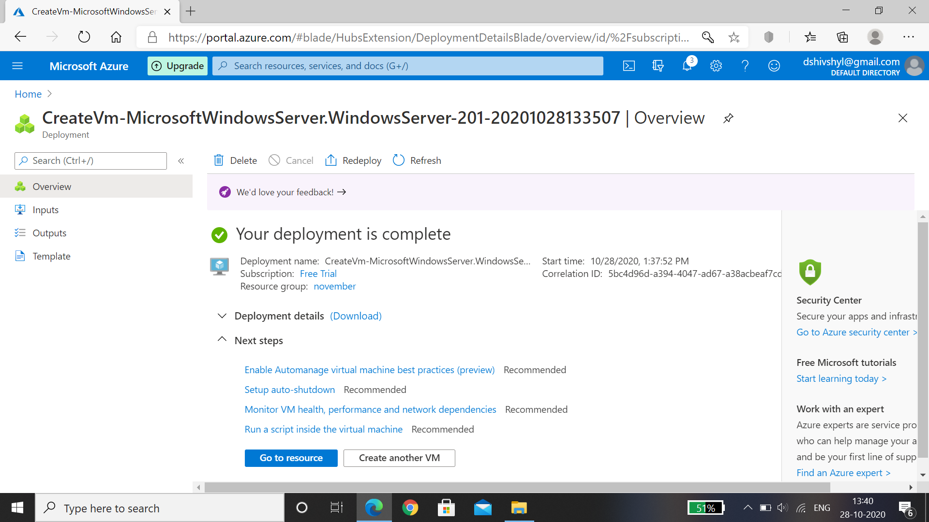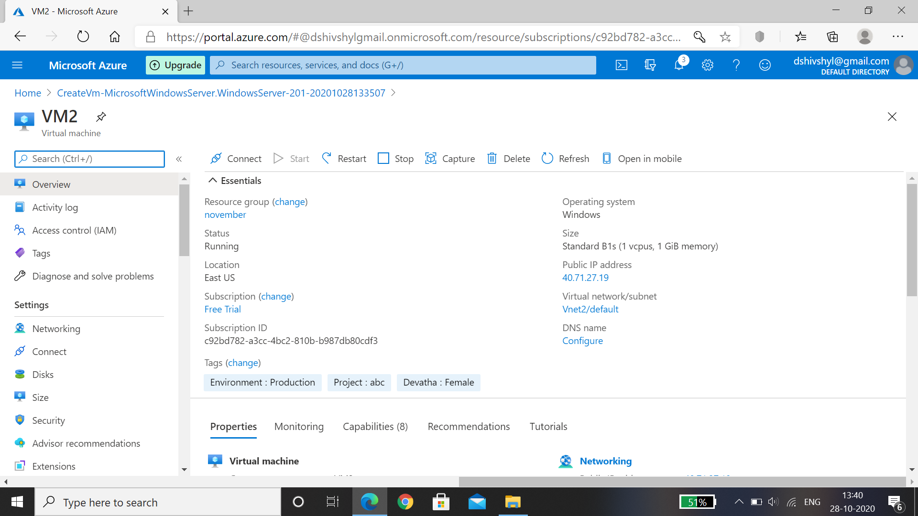

VM2 is created for the resource group of Vnet2.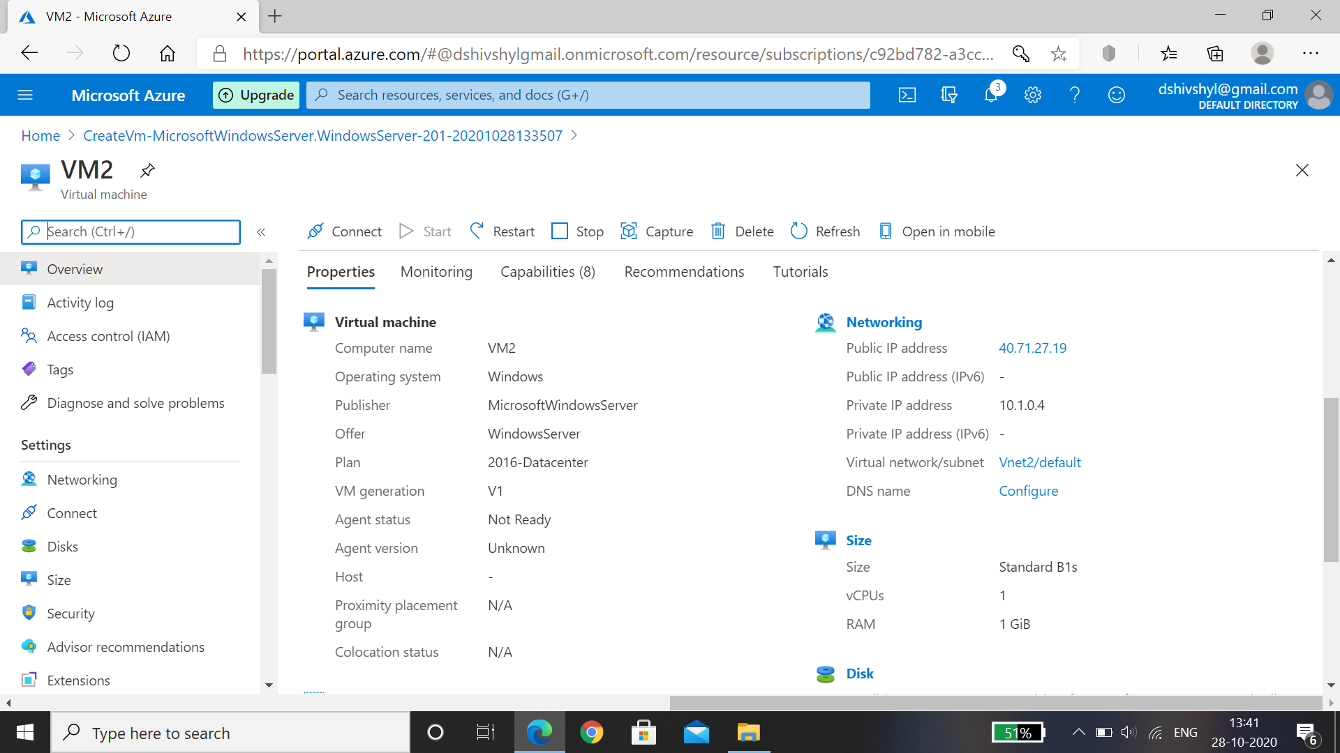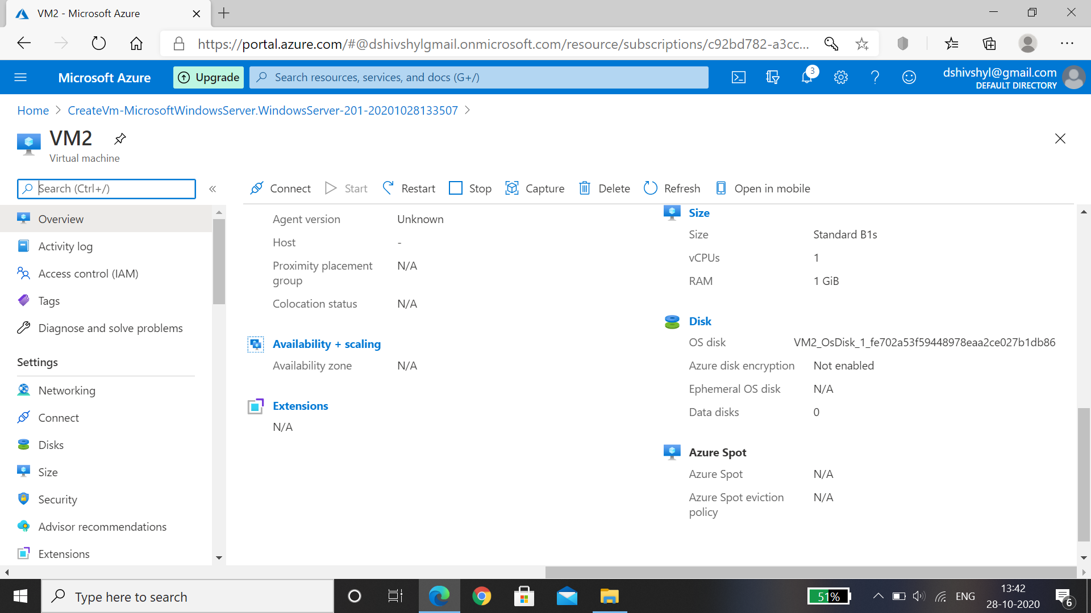

Hence Create VM each Vnet1 and 2 is showed.

# Assign Public IP to VM in Vnet1.

1. Login to Microsoft **Azure** portal.
2. Click “Virtual Machines” .
3. Click “Add”.
4. Add the basic information about the **virtual machine** to be **set** up.
5. In the Networking tab, for **Public IP** click “Create new” and name pip01.
6. Under **assign**, select dynamic.
7. Click OK.



Hence Public IP address is assigned to VM in Vnet 1.

# Peer Vnet 1 and 2.

Peering- The exchange of data directly between internet service providers, rather than via the internet.

* Step 1 : Create two virtual networks Vnet 1 and 2.
* Step 2:In the Search box at the top of the Azure portal, begin typing Vnet1 When **Vnet1** appears in the search results, select it.

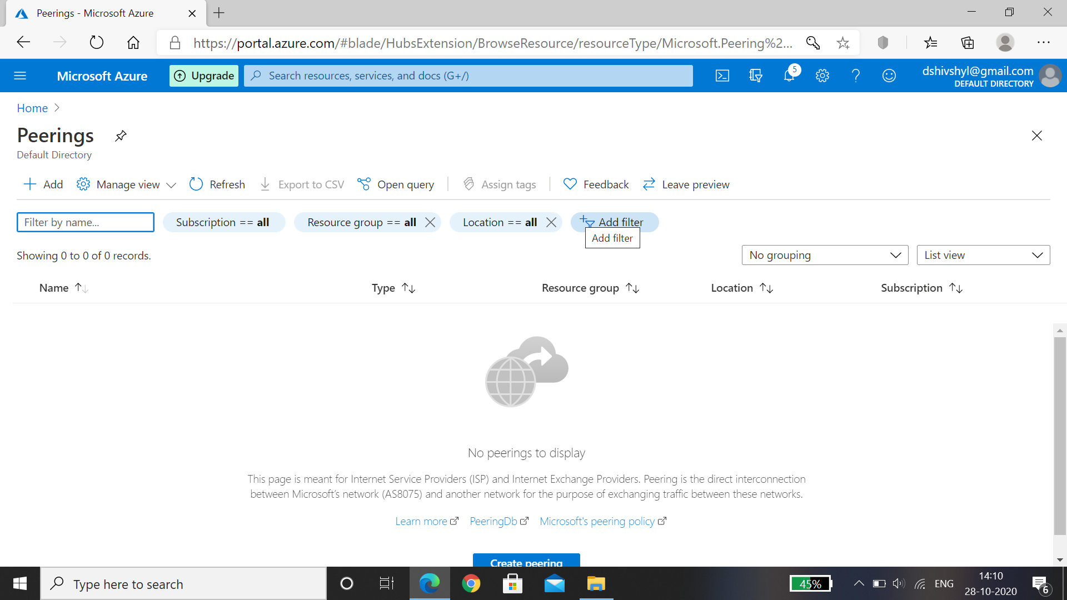

Step 3: Select **Peerings,** under**Settings**, and then select **Add.**

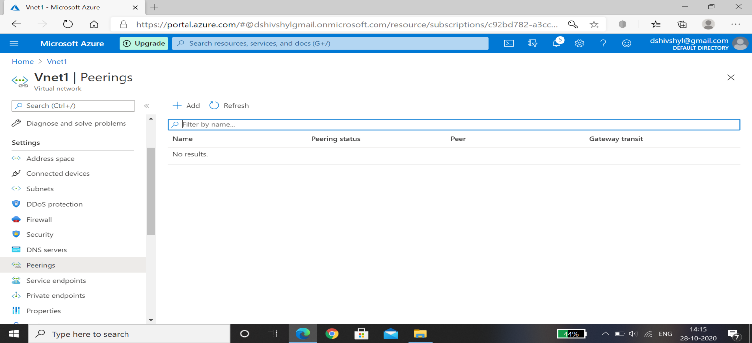

Step 4:Enter, or select, the following information, accept the defaults for the remaining settings, and then select ok

Name of the peering from Vnet1 to Vnet2: Vnet1toVnet2

Subscription: free trail

Virtual network: vnet2(November)

Name of the peering from Vnet2 to Vnet1:Vnet2to2

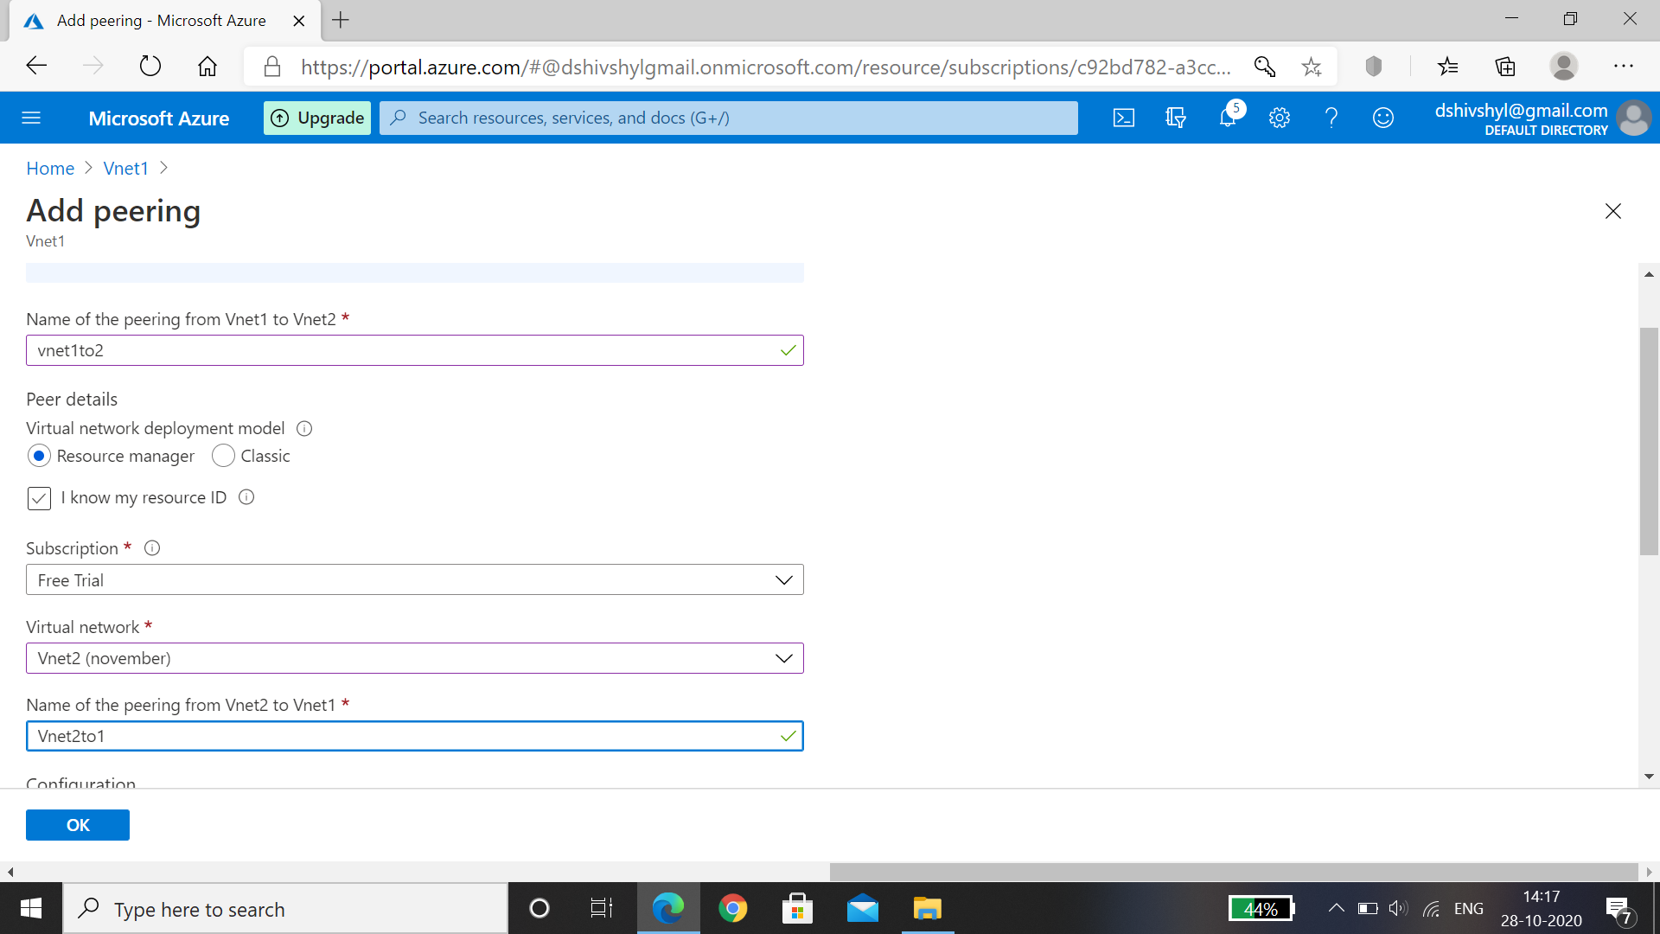

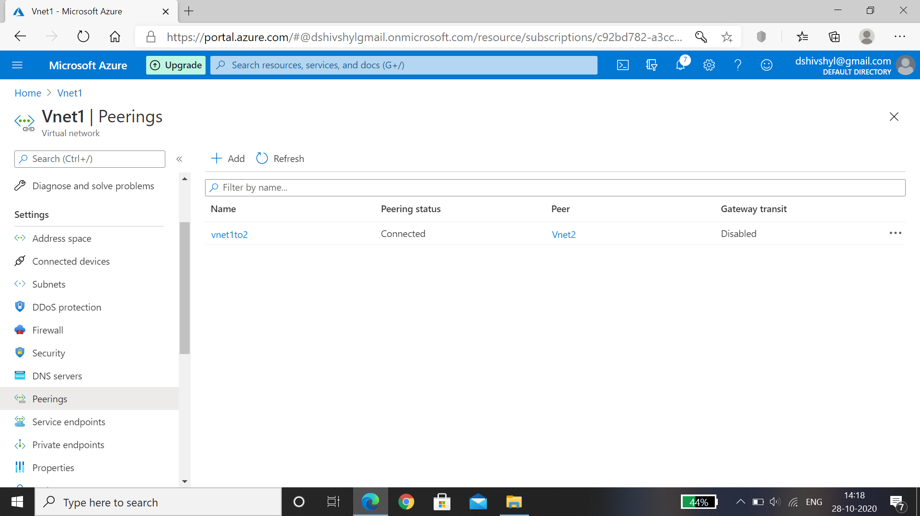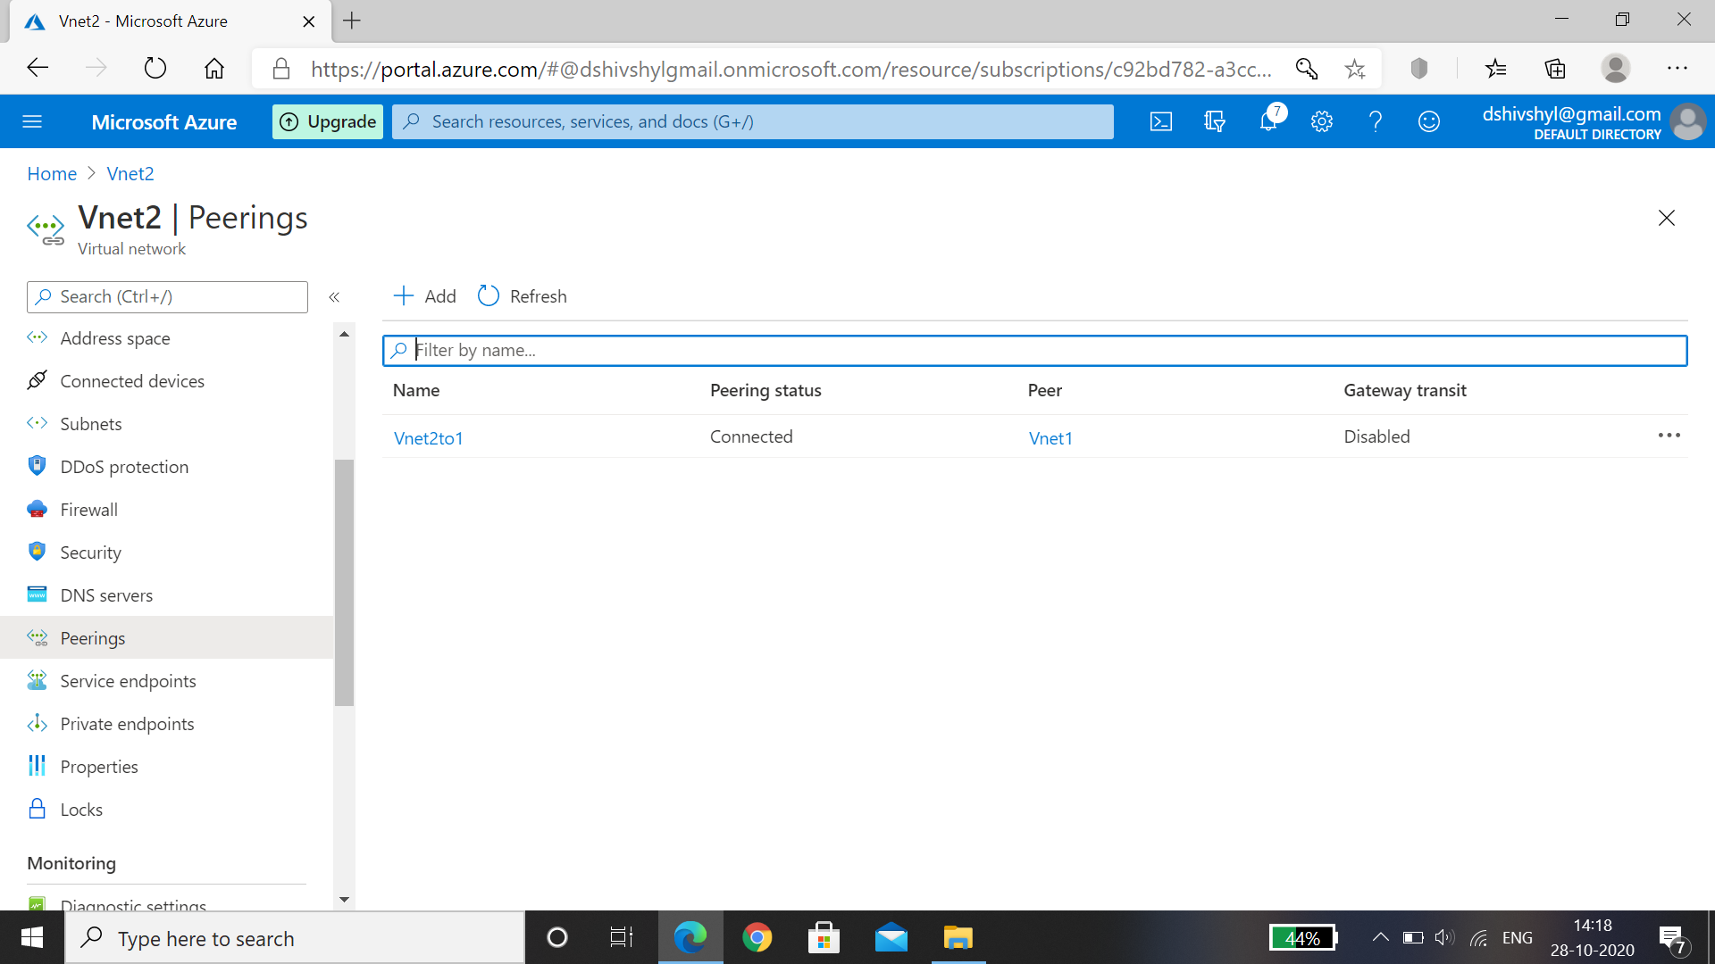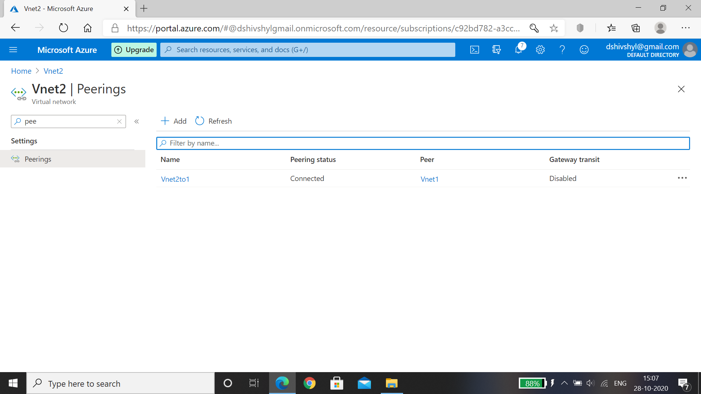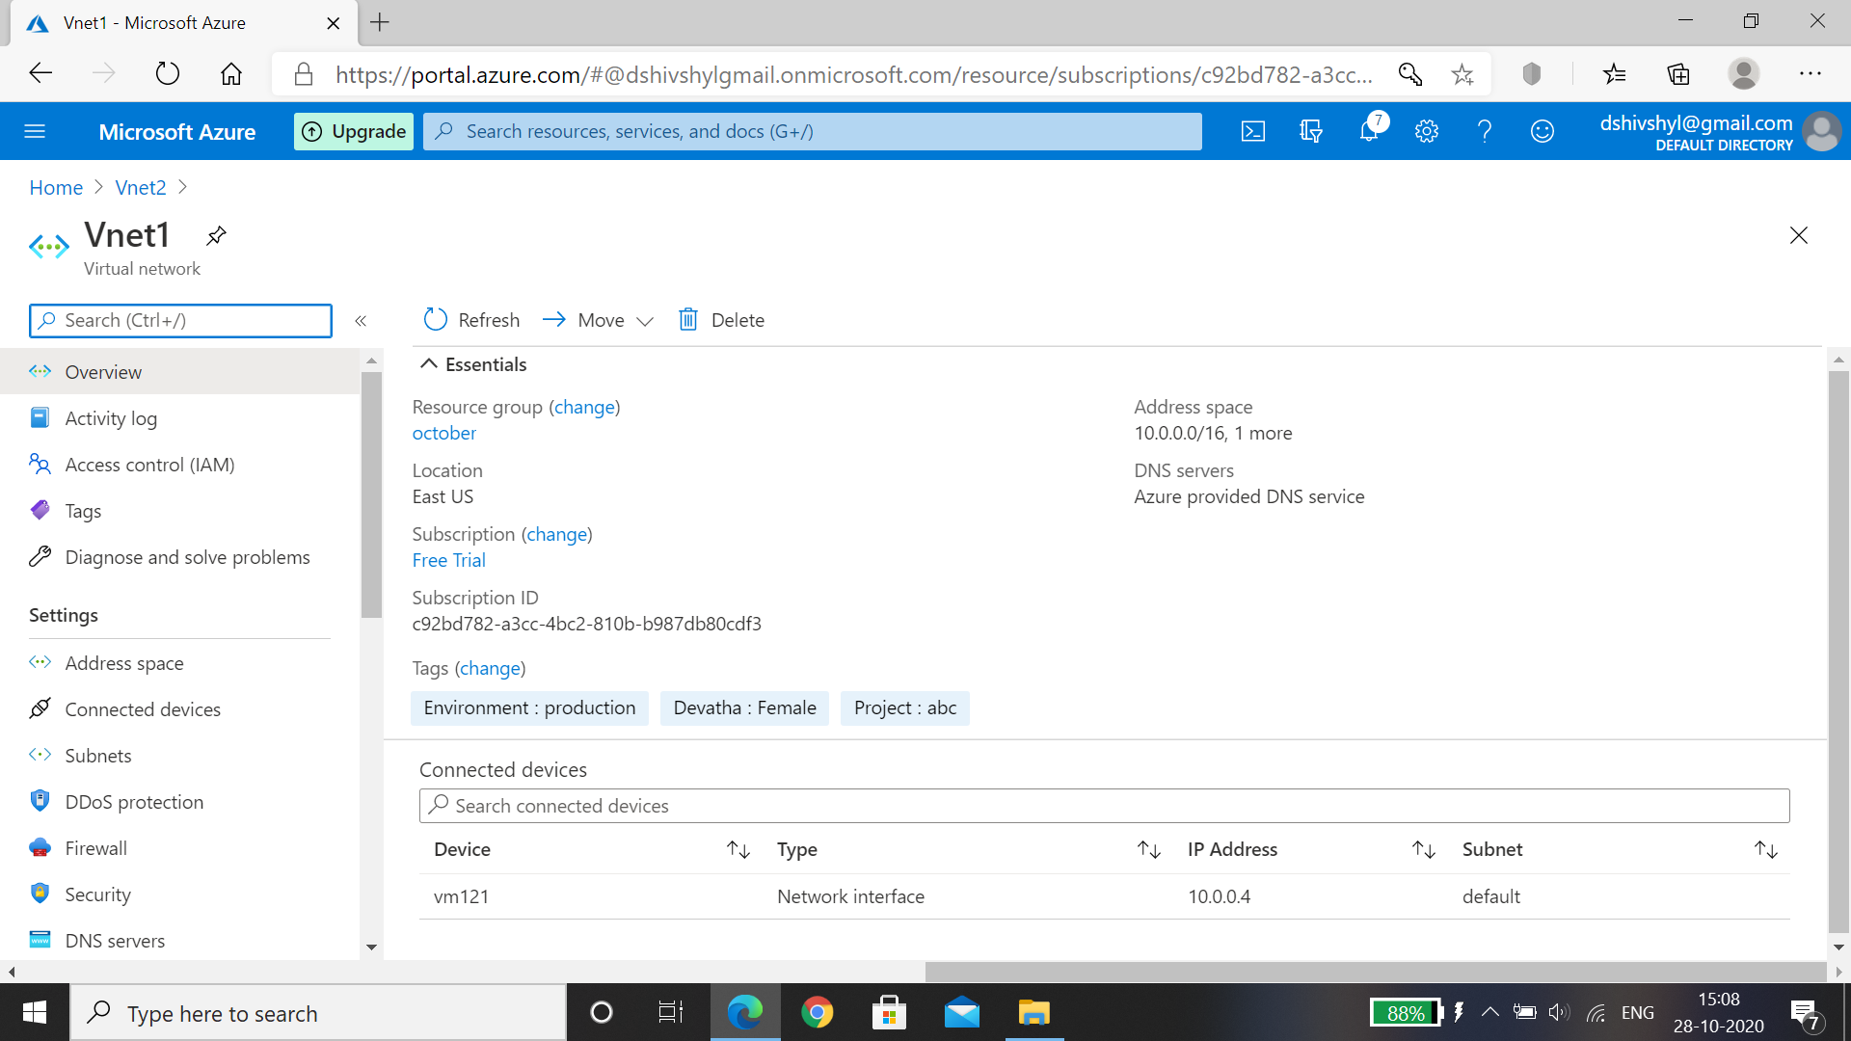

Hence Peerings for Vnet 1 and 2 is successful.

# Login to VM1 and if peering is successful you should be able to login to VM in Vnet2.

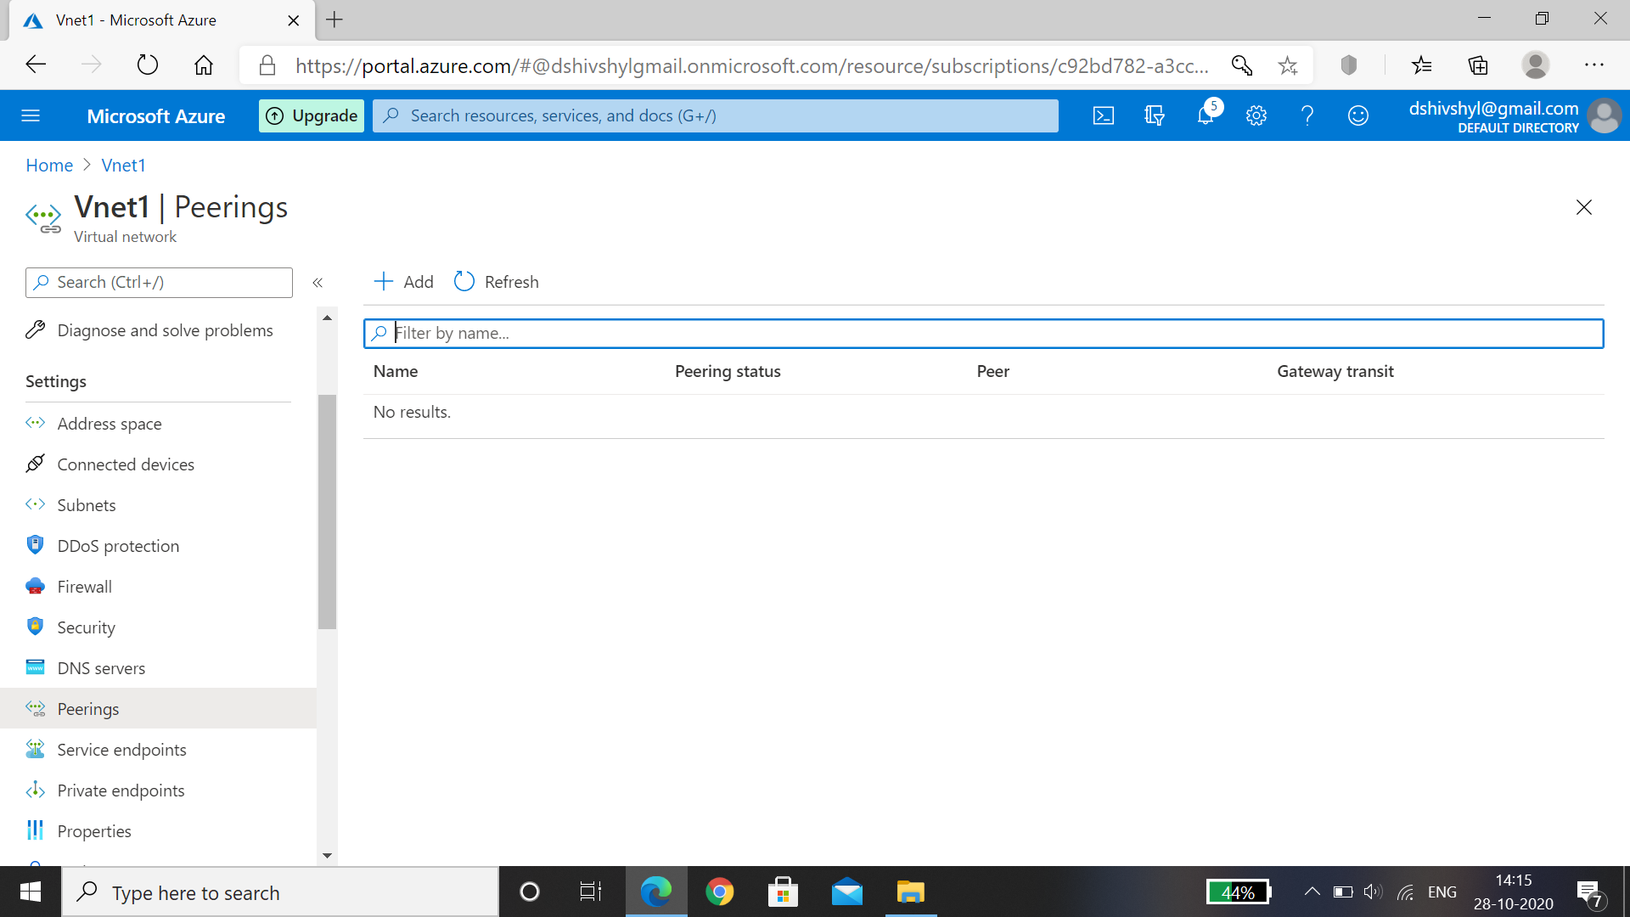

Hence Peerings is successful.

# Create a Data disk and attach to VM1

1. Go to the [Azure portal](https://portal.azure.com/) to add a data disk. Search for and select Virtual machines.
2. Select a VM1from the list.
3. On the VM1 page, select Disks.
4. On the Disks page, select Add data disk.
5. In the bottom left for the new disk, select Create and attach a new disk.
6. In the Create disk page, type in a name for the disk and adjust the other settings as necessary. When you're done, select Create.
7. In the Disks page, select Save to save the new disk configuration for the VM.
8. After Azure creates the disk and attaches it to the virtual machine, the new disk is listed in the VM! disk settings under Data disks.

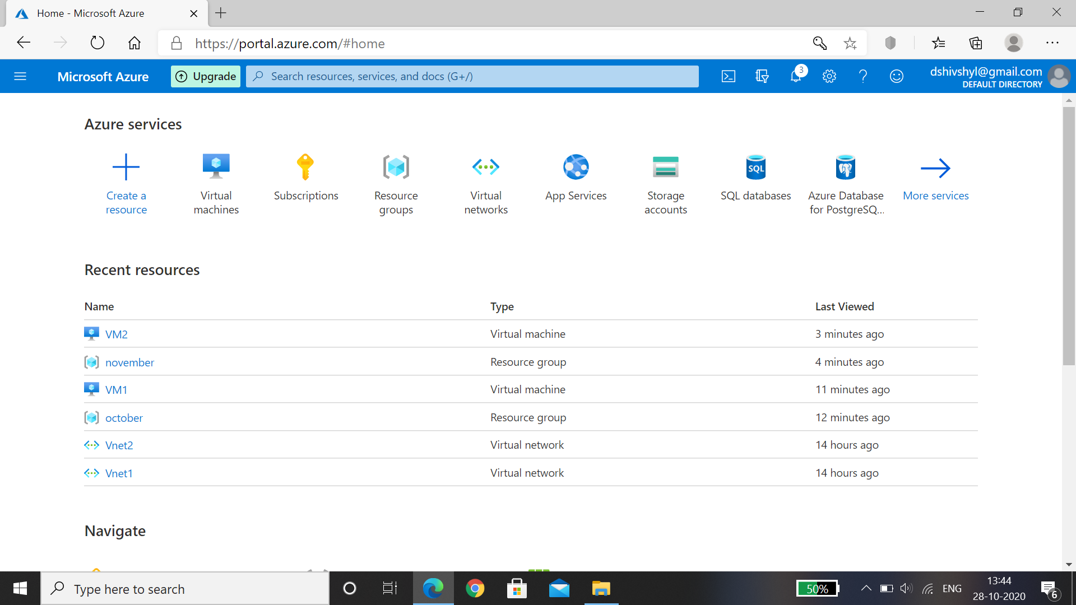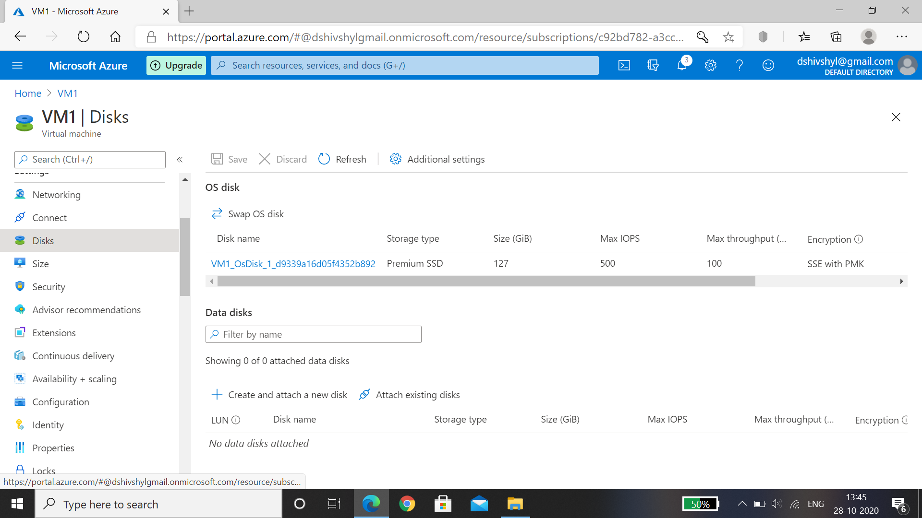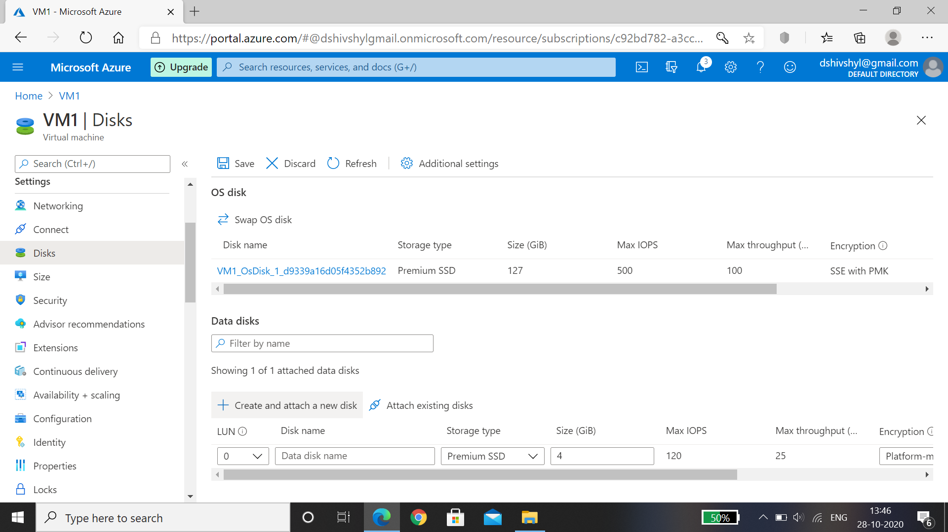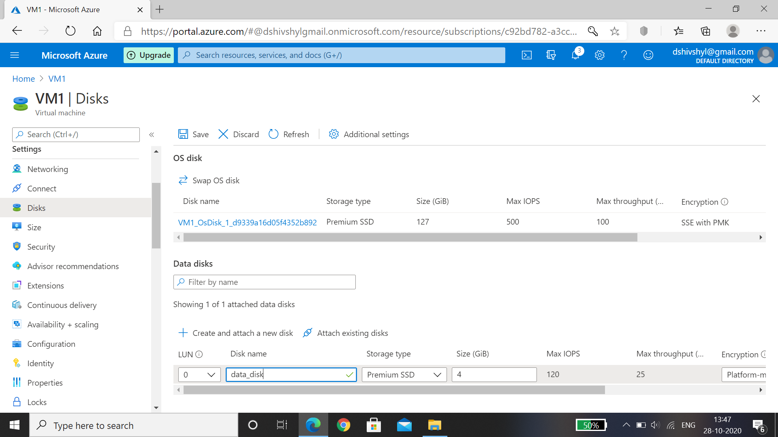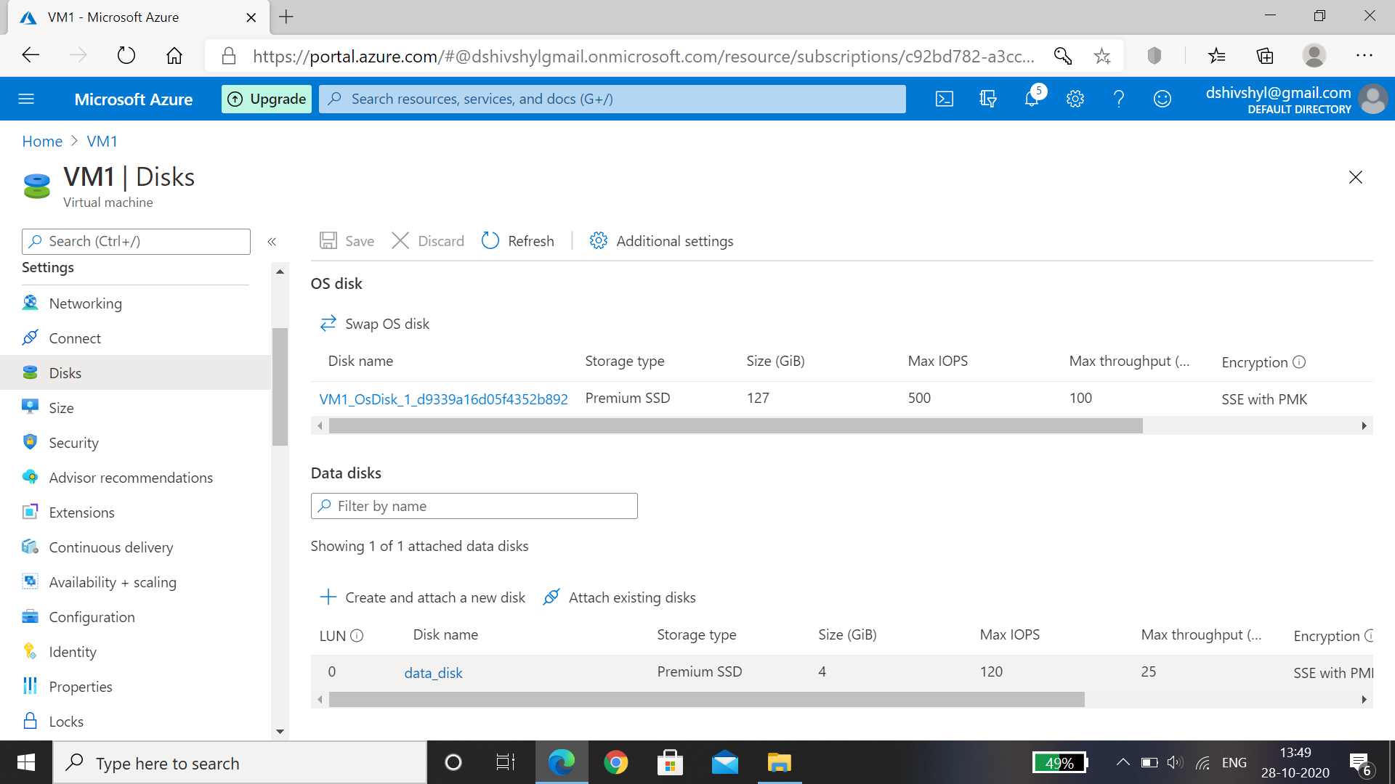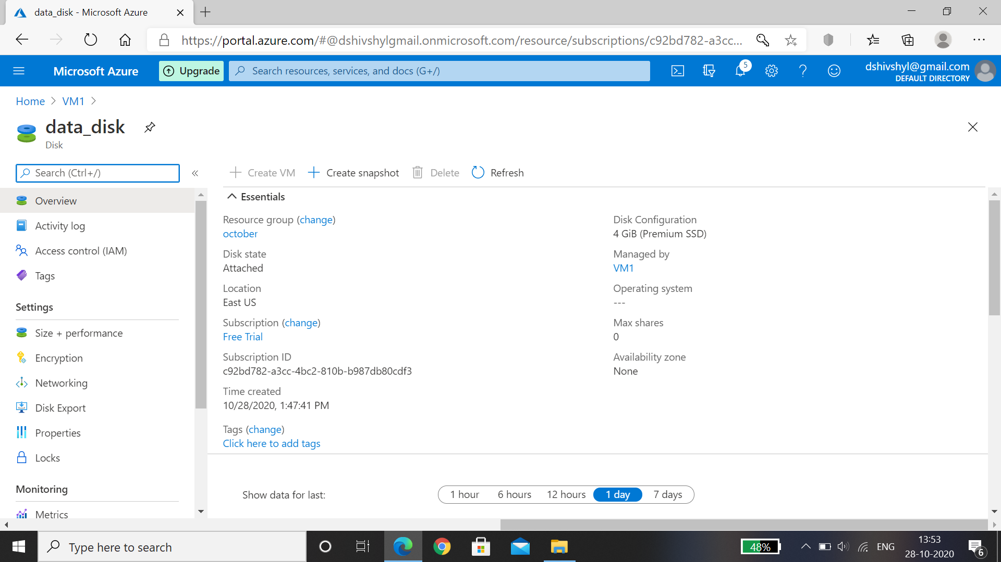

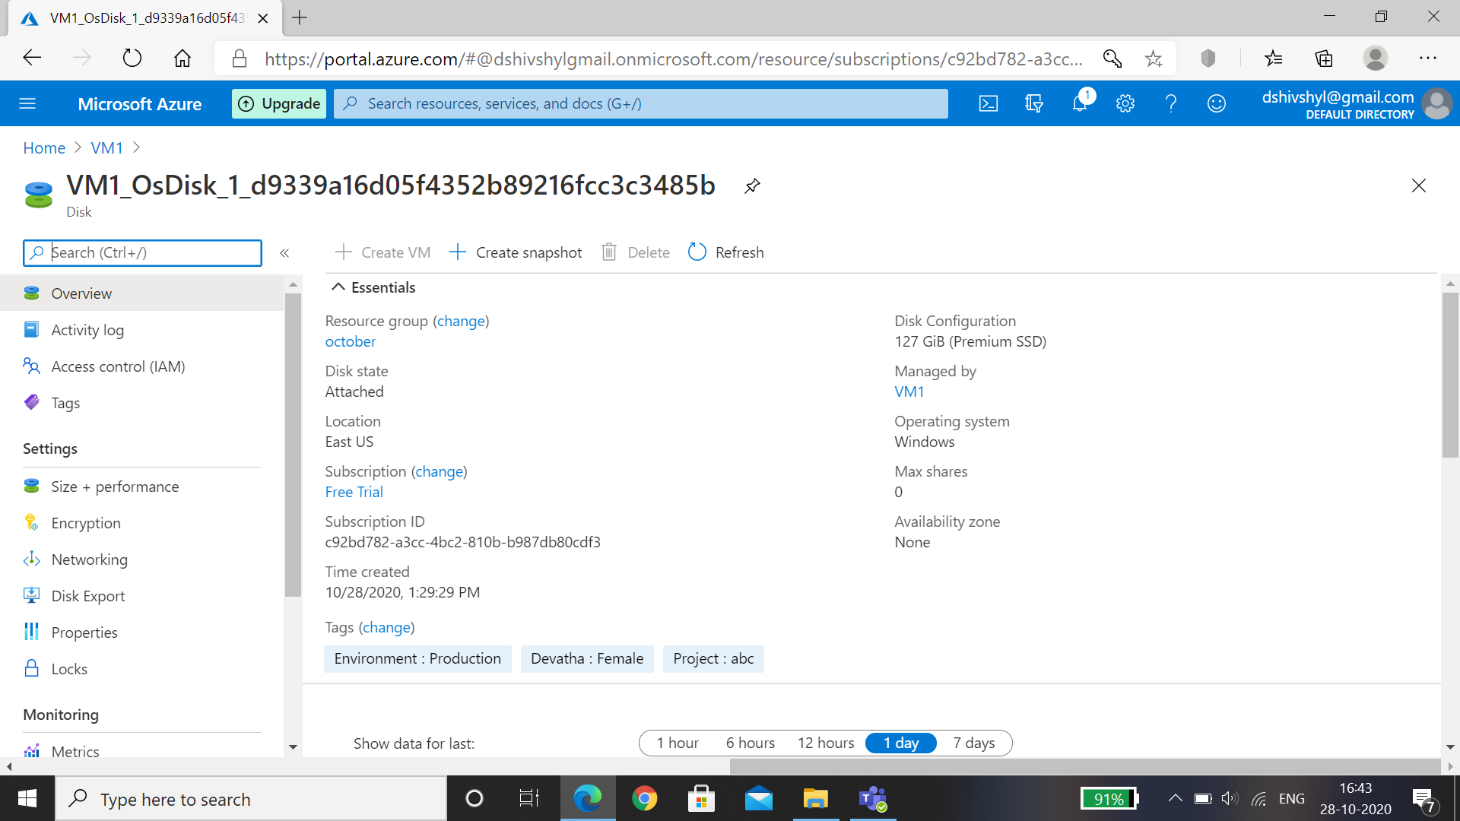

# Logon to VM and initialize the disk.

1. logo to the VM.
2. Select the Windows Start menu inside the running VM and enter mstsc in the search box. The Disk Management console opens.
3. Disk Management recognizes that you have a new, uninitialized disk and the   window appears.
4. Verify the new disk is selected and then select OK to initialize it.
5. The new disk appears as unallocated. Right-click anywhere on the disk and select New simple volume. The New Simple Volume Wizard window opens.
6. Proceed through the wizard, keeping all of the defaults, and when you're done select Finish.
7. Close Disk Management.
8. A pop-up window appears notifying you that you need to format the new disk before you can use it. Select Format disk.
9. In the Format new disk window, check the settings, and then select Start.
10. A warning appears notifying you that formatting the disks erases all of the data. Select OK.
11. When the formatting is complete, select OK.

